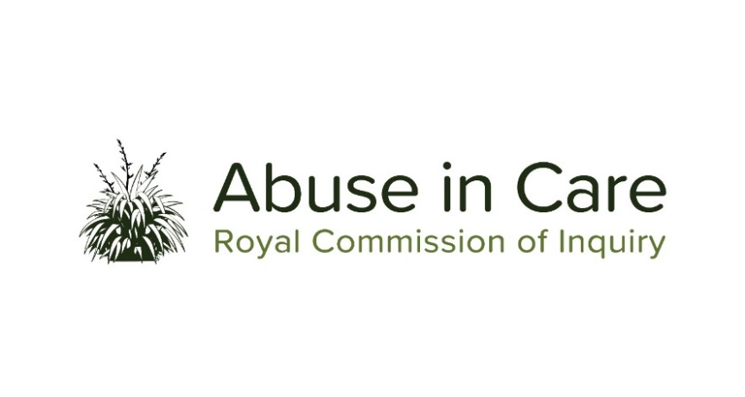

**INVESTIGATION INTO ABUSE OF CHILDREN IN STATE RESIDENTIAL CARE**

**A CASE STUDY**

1. As part of its investigation into abuse in State residential care the Inquiry will undertake a case study, including public hearings, into the abuse and neglect of children and young people in the following residences (together “the case study residences”):

* Epuni Boys’ Home (Lower Hutt)
* Hokio Beach School (Horowhenua)
* Kohitere Boys’ Training Centre (Horowhenua)
* Ōwairaka Boys’ Home (Auckland)
* Bollard Girls’ Home (Auckland)
* Kingslea Girls’ Home / Burwood Training Centre (Christchurch)
* Moerangi Treks (Urewera)
* Whakapakari (Great Barrier Island)
* State-owned Family homes (nationwide).

1. The Inquiry will investigate:
   1. The context in which the case study residences were established, operated and closed;
   2. The circumstances in which children and young people were placed in the case study residences and the appropriateness of those placements;
   3. The nature and extent of any abuse of children and young people placed in the case study residences;
   4. The factors that caused or contributed to such abuse;
   5. The State’s obligations under Te Tiriti o Waitangi / the Treaty of Waitangi;
   6. Factors underpinning relevant policy and legislative settings during the period 1950 to present day;
   7. Whether children and young people in the case study residences experienced abuse differentially whether by virtue of disability, mental health status, ethnicity, gender, gender identity and/or sexual orientation;
   8. The immediate, long-term and intergenerational impacts of abuse on victims and survivors of the case study residences and their families and whānau, hapū, iwi and communities. This will include consideration of:
      1. Te Tiriti o Waitangi / the Treaty of Waitangi and principles of tikanga Māori when considering the impacts of abuse on Māori and their whānau, hapū and iwi;
      2. Pacific cultural norms and values when considering the impact of abuse among Pacific people;
      3. Particular impacts related to disability and mental illness, including additional barriers to understanding and recognising abuse, disclosing abuse, accessing specialist wellbeing supports to respond to trauma, and receiving redress;
      4. Particular impacts of abuse on victims and survivors given their gender and age at the time.
   9. The adequacy of any actions by the State to prevent and respond to abuse of children and young people in the case study residences, including the extent to which Police and government agencies protected children and young people from abuse, and held perpetrators to account;
   10. The State’s obligations under domestic and international law, including human rights law;
   11. The adequacy of the State’s redress and rehabilitation response to victims and survivors of abuse in the case study residences.
2. The investigation will also assess and make recommendations on:
   1. Any gaps in legislation, policy, processes, rules, standards and practices, including oversight mechanisms, that require change to prevent and respond to abuse of people in care;
   2. Any changes required to redress, rehabilitation and compensation processes for  victims and survivors who were abused in care.
   3. Any other steps the State should take to address the harm caused by abuse in care.
3. Where relevant, the Inquiry may make findings of fault or that relevant standards have been breached, or both. The Inquiry does not have the power to determine the civil, criminal or disciplinary liability of any person, but may make recommendations that further steps be taken to determine liability.
4. The case study’s first public hearing will consist of survivor voices from the case study residences. Subsequent public hearings will focus also on systemic factors and accountability, and will include evidence from the relevant government agencies, including former staff.