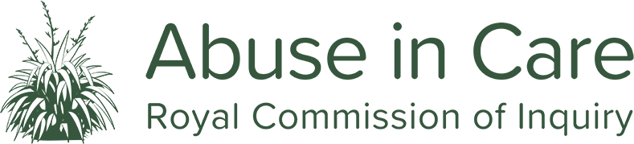
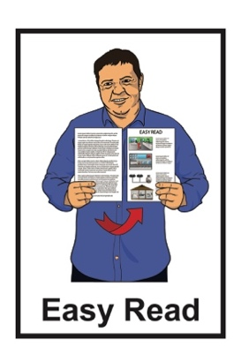

Whanaketia – Through pain and trauma, from darkness to light
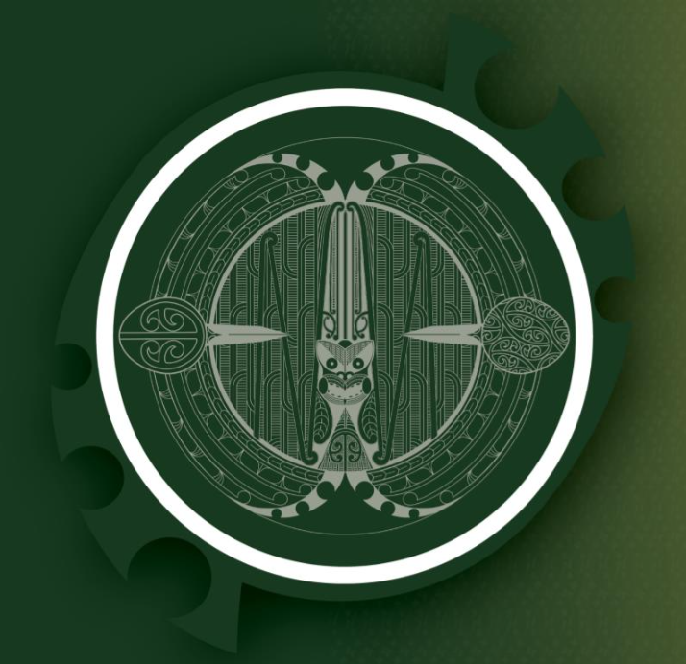

Easy Read summary – Part 1
Published: October 2024

Before you start


This Easy Read document is about a report written by the Royal Commission of Inquiry into Abuse in Care.


Some of the information and pictures in this document are very upsetting.

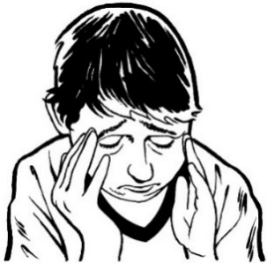
This document is about people being badly hurt by people who were meant to look after them.

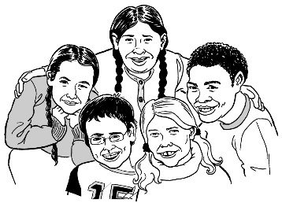
The people who were hurt include:
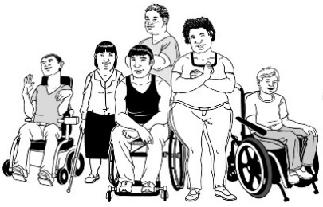
children / young people
disabled people
people who experience mental distress.

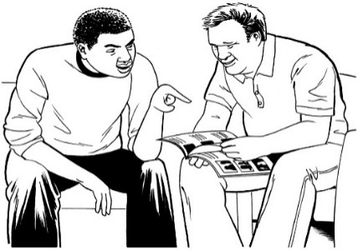
Before you read this document you might want to make sure you:
- are in a safe place
- have people who can support you.

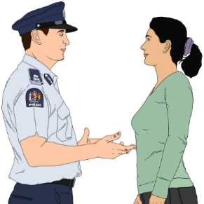
If you do not feel safe call the police on 111.

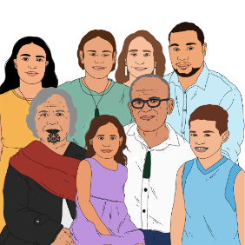
If you are upset after reading this document you can talk to your:
- whānau / family
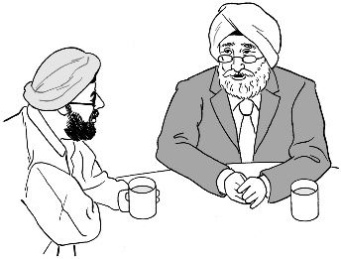
- friends.

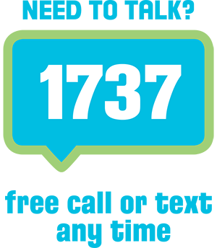
You can also talk to a counsellor at Need to Talk by:
calling 1737
texting 1737.



It does not cost any money to call / text 1737.


You can also find support through the Survivor Experiences Service.


You can contact the Survivor Experiences Service by:

- phone: 0800 456 090
- text: 8328

- email:

contact@survivorexperiences.govt.nz
It does not cost any money to call the Survivors Experiences Service.


You can find information from the Survivor Experience Service about support at:

survivorexperiences.govt.nz/
support-services/


You can find information from the Survivor Experiences Services for disabled survivors at:

survivorexperiences.govt.nz/for-survivors/disabled-survivors/

What you will find in here

Page number:
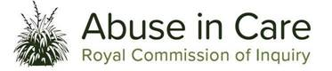
About the Royal Commission
of Inquiry into Abuse in Care 7
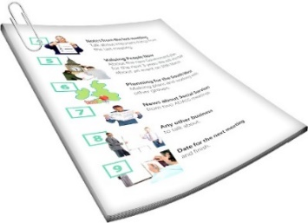

What is this document about? 11


About the abuse 16


How did the abuse happen? 35

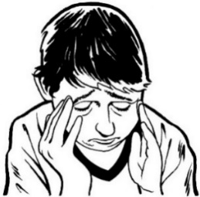
How has the abuse
affected survivors? 49

Page number:
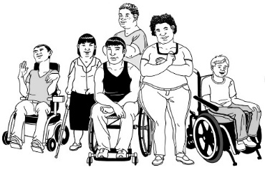

How does abuse affect groups
of people? 59


The cost of abuse 77

About the Royal Commission of Inquiry into Abuse in Care

The Royal Commission of Inquiry into Abuse in Care looked into abuse that happened to people
in care.


The Royal Commission of Inquiry into Abuse in Care is also called the Commission.

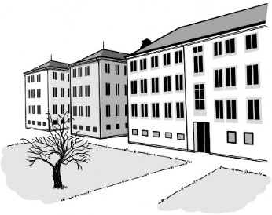
In this document being in care means that the Government or a faith-based institution took responsibility for your care.


Faith-based institutions are organisations that are connected to a religious group or belief.

For example a church is a faith-based organisation.


Having responsibility for your care means they are:
in charge of your care

can be blamed if:
- something is done wrong
- they do not do something they should.

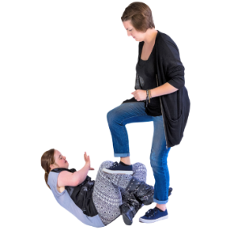
Abuse can be:
- physical – a person kicking or hitting you
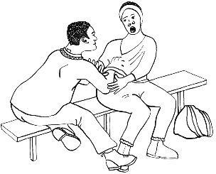
- sexual – a person doing sexual things to you that you do not want them to such as:
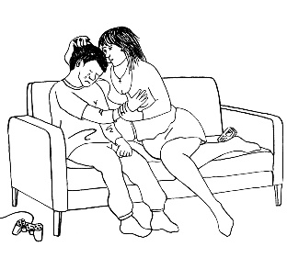
- touching your body or private parts
- kissing you
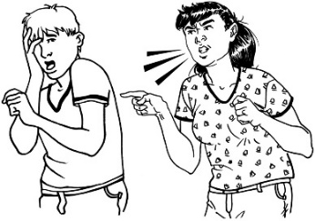
- making you have sex with them – this is called rape
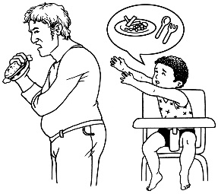
- emotional – a person yelling or saying things to you that are not nice
- neglect – a person not giving you the things or care you need.


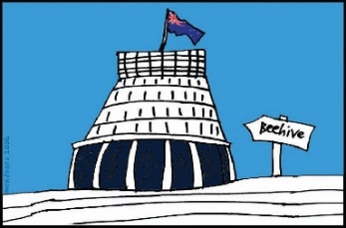
The Commission is not part of the Government.

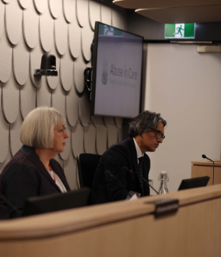
The Government cannot tell the Commission:
how to do its work
what it should find out
what it should say should happen next.


The Commission is not part of any faith-based organisations like churches.

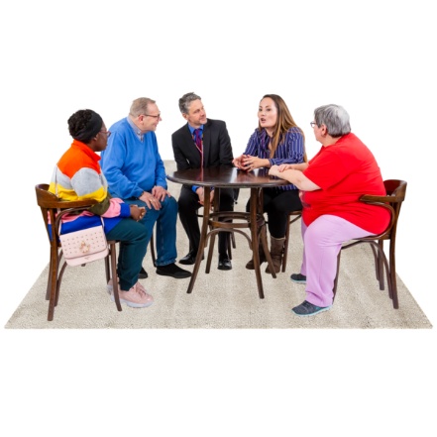
The Commission calls people who have been through abuse in care survivors.

What is this document about?

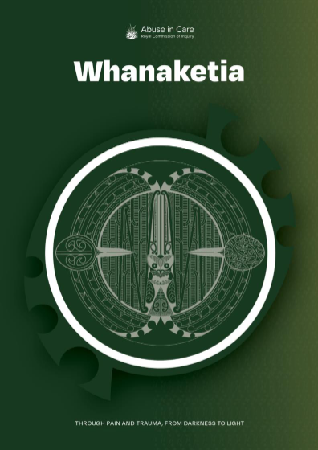
This document is Part 1 of an Easy Read summary of a report called:

Whanaketia – Through pain and trauma, from darkness to light.

A summary is a shorter version of the report.

This is the final report by the Commission.


The Commission was set up to look into abuse in care between 1950 and 1999.

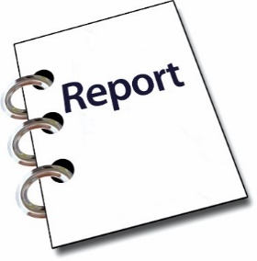
Now it has done its work it has made this report.

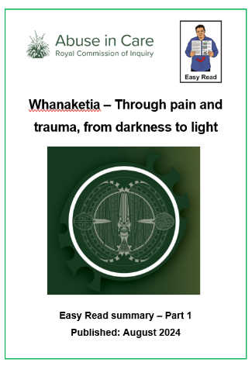

We have split this Easy Read translation into 2 parts.

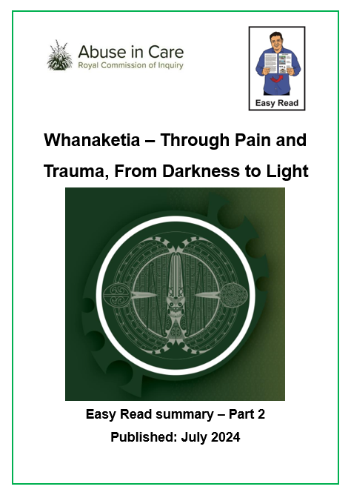

This part is about what the Royal Commission found out.

Part 2 looks at what needs to happen now.


You can find Part 2 at this website:

www.abuseincare.org.nz
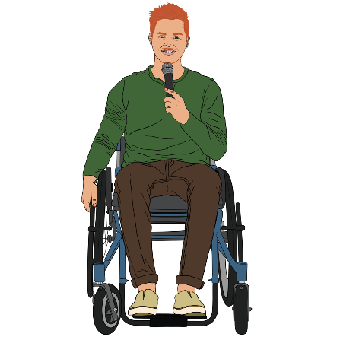

Lots of survivors told the Commission about what happened to them when they were in care.

Information from what survivors said has been used to make this report.

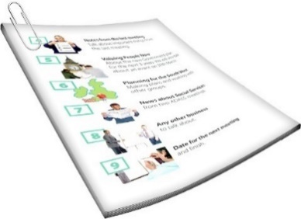
This Easy Read document is long.

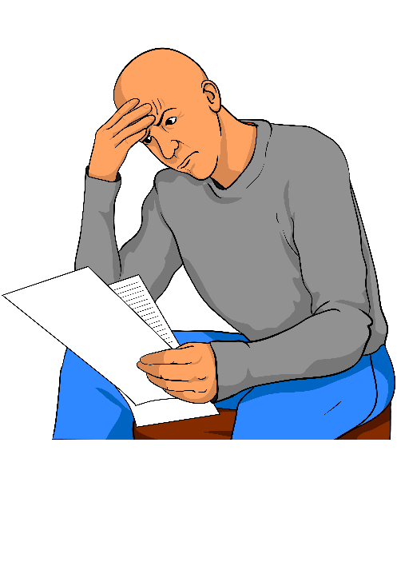
We have chosen not to make it shorter because of how important all the information in it is.

You might want to read it a bit at a time.

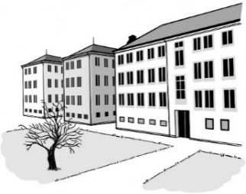
State / faith-based institutions were meant to care for people.

Instead people were abused in terrible ways.

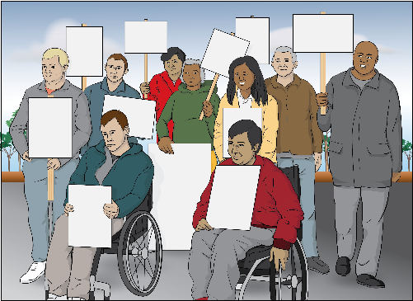
People did not get their rights like:
human rights
the rights Māori have under
te Tiriti o Waitangi.
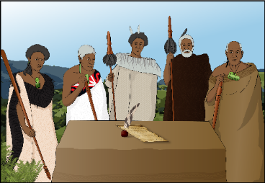
Te Tiriti o Waitangi / The Treaty of Waitangi is an important agreement between Māori and the British Crown.

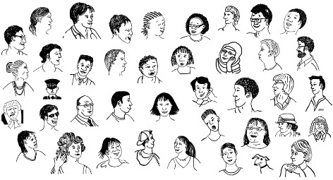
We think more than half a million people were in care in the time the Commission looked at which was between:
1950
and
1999.

We think up to 2 hundred thousand of these people were abused.

This is more than 1 in every 3 people in care.

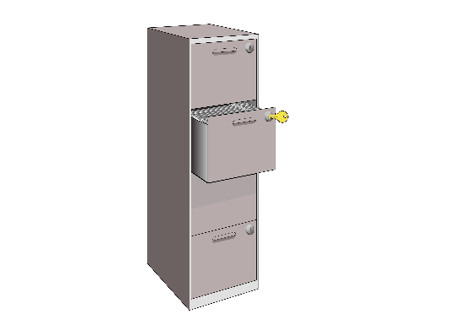
We will never know how many people were abused because information:
was not written down
was lost
was destroyed.
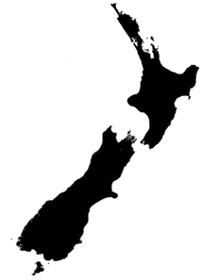

That this abuse happened is a disgrace for New Zealand.

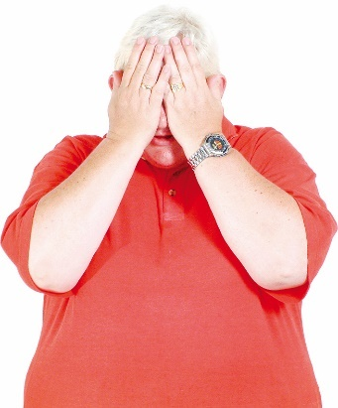
A disgrace is something we should feel ashamed of.

About the abuse


Abuse / neglect almost always started from the first day someone was in care.

It often kept happening for their whole time in care which could be many years.
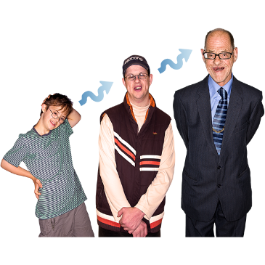

For some people this was all their life.

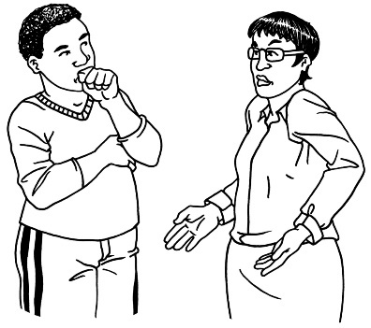
People in care were treated in ways that showed people did not care about them.

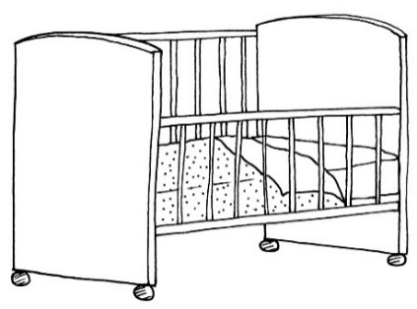
Babies were left in cots with no hugs or other ways of caring for them.
Many people in care did not get the things they needed like enough:
food
clothes to wear.

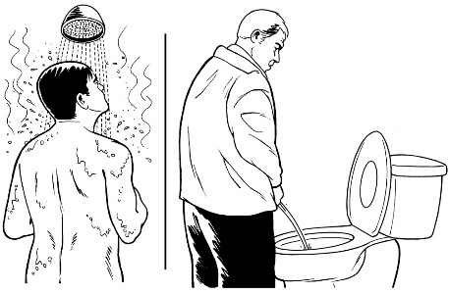
Some people were not allowed privacy when:
washing themselves
using the toilet.

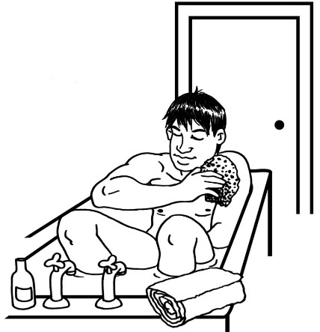
Privacy is when you get the chance to be:
- on your own
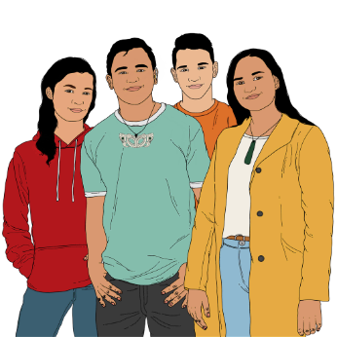
- without anyone else watching.

Māori were often treated worse than other people in care.
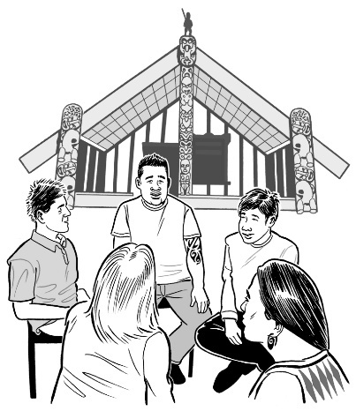
Māori people in care were not allowed to learn:
mātauranga
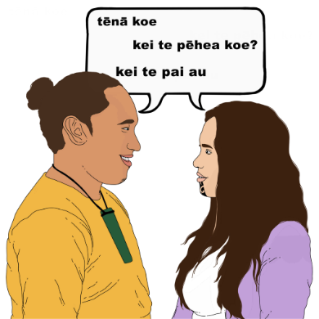
tikanga / Māori ways of doing things
te reo Māori / the Māori language.

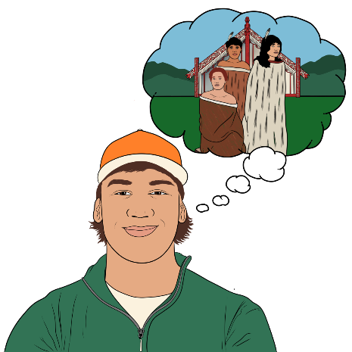
Mātauranga is:
Māori ways of knowing things
information Māori have known for a very long time.

Sometimes violence was used to stop Māori learning these things.

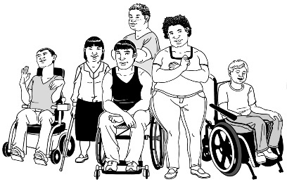
Some Māori in care were also abused for being:
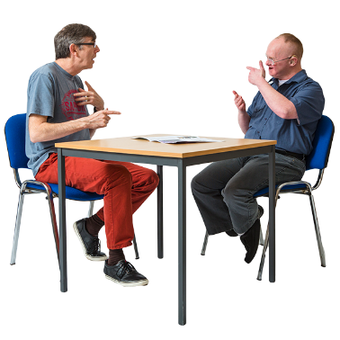
disabled
Deaf
Takatāpui.


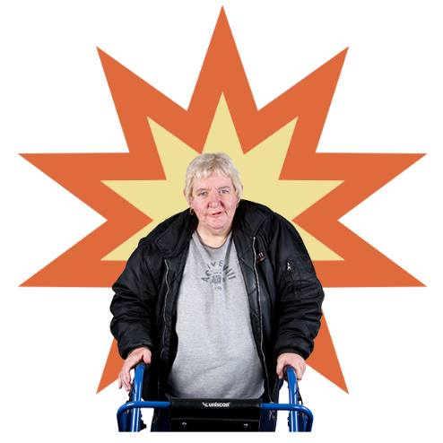
This abuse often compounded.

Compounded means they:
added together
made each other bigger / worse.

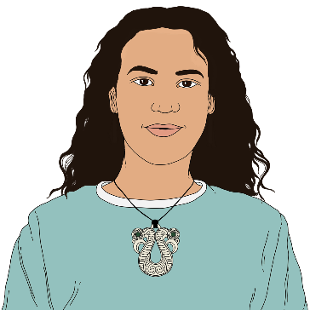
Takatāpui is a word for Māori who:
have 1 of the rainbow identities
have a similar identity but in a Māori way.
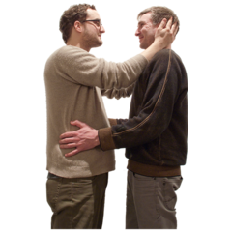
Rainbow means people who are:
- lesbian
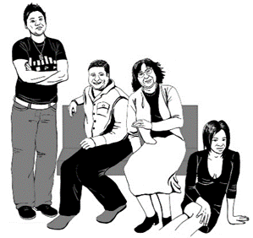
- gay
- bisexual
- transgender
- takatāpui
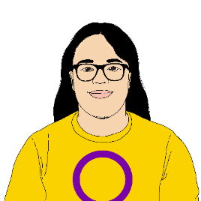
- queer
- intersex
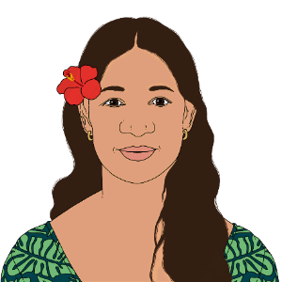
- asexual
- MVPFAFF+

- + is for other people who fit in similar groups.

MVPFAFF+ includes:
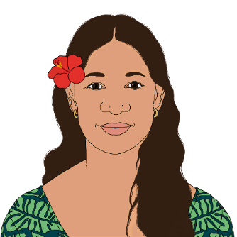
Samoan people who are fa’afafine
- Tongan people who are:
- leiti
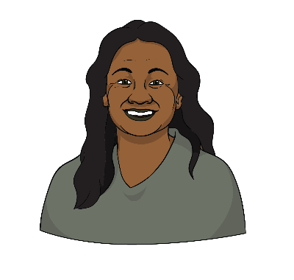
- fakaleiti
- Niuean people who are fakafifine
- Cook Islands people who are akava’ine
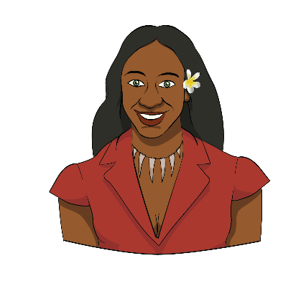
- Tuvaluan people who are pina
- Tahitian and Hawaiian people who are māhū
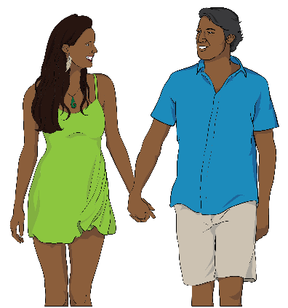
- Fijian people who are vakasalewalewa
- Papua New Guinean people who are palopa.
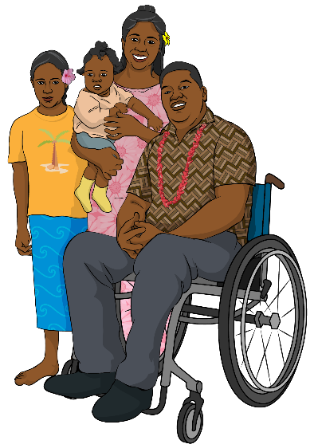
Pacific people also got:
racial abuse
cultural neglect.


This included not being able to:
know about who they are in their culture
learn about their culture
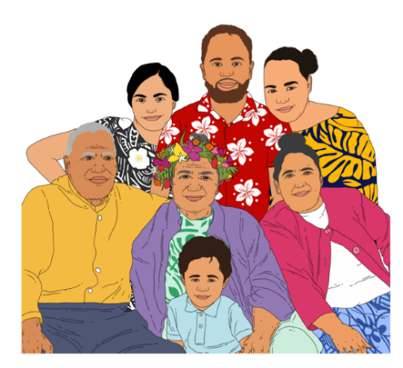
speak their languages
do things that are part of their culture
know their kainga / family.

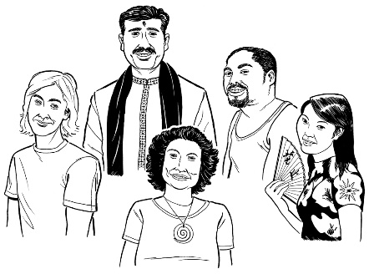
Culture is a way of:

- thinking that a group shares

- doing things as a group.
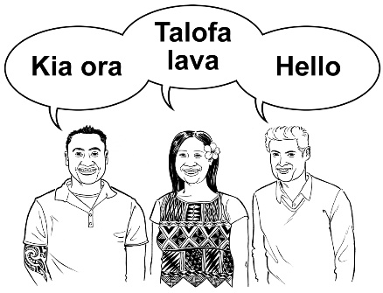

There are many different cultures in
Aotearoa New Zealand.
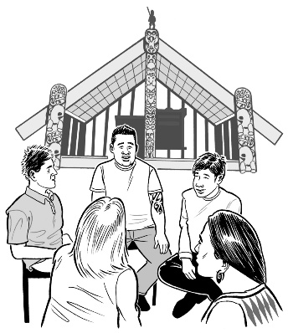

Some examples of the different cultures are:

- Māori culture
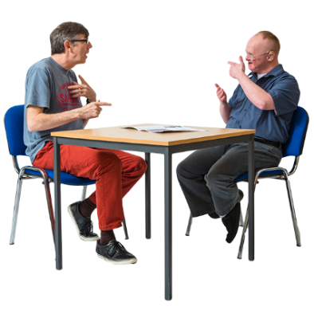
- Pacific culture

- Deaf culture.

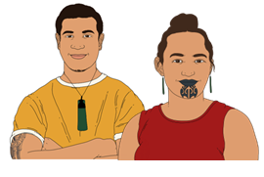
Many Pacific people in care were also Māori.

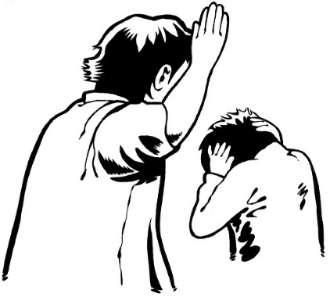
This means they experienced more than 1 kind of:
racial abuse
cultural neglect.

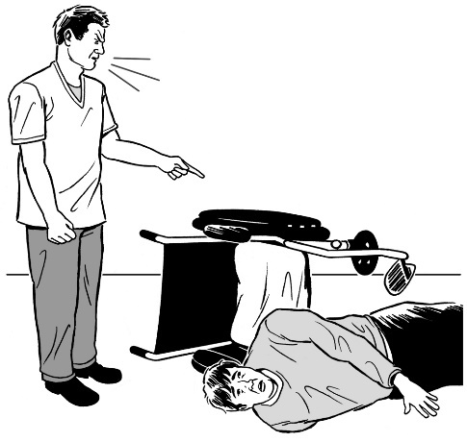
Deaf / disabled survivors experienced abuse based on:
ableism
audism.

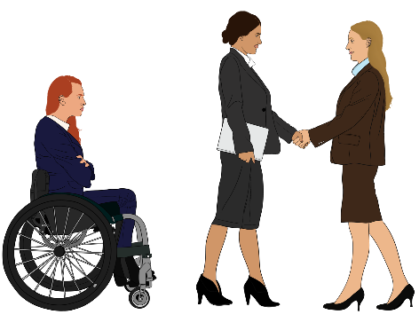
Ableism is when disabled people are treated:
badly for being disabled
as less important than people who are not disabled.

Audism is when:
- Deaf people are treated badly for being Deaf
the ways hearing people do things are thought to be better.

This often meant things like not being allowed to:
use sign language
be part of Deaf culture.
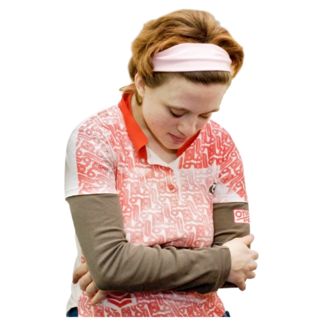

The bad treatment of disabled people in care includes survivors who experienced mental distress.

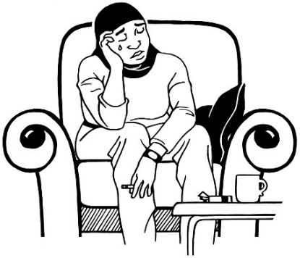
Mental distress is when people are having a very hard time with their mental health.
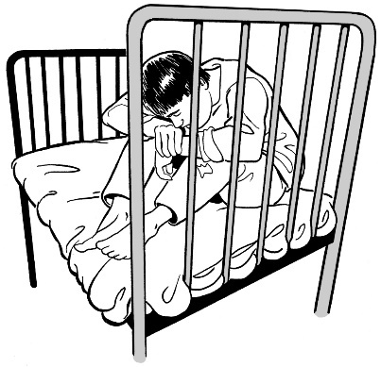
Disabled and Deaf survivors were not given stimuli to:
grow
develop / grow up as a person.

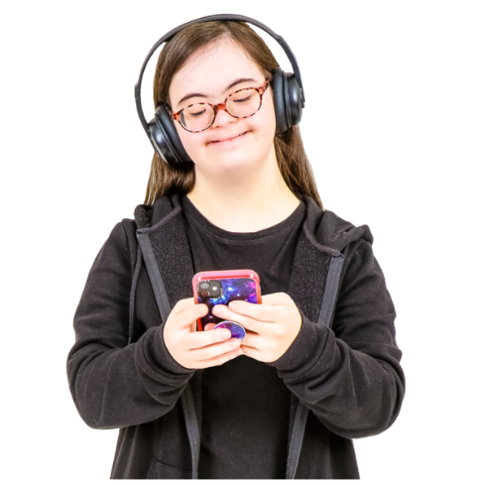
Stimuli are things that make people feel interested in things like:
music / talking
ideas
things to look at.

Stimuli are important for:
learning
getting to know the world around us.

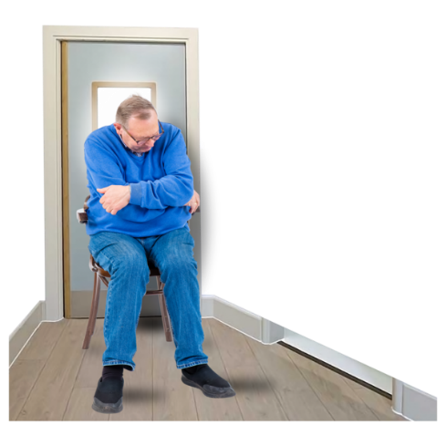
Many Deaf / disabled survivors were:
kept away from society / other people
not paid attention to
not allowed a basic education.

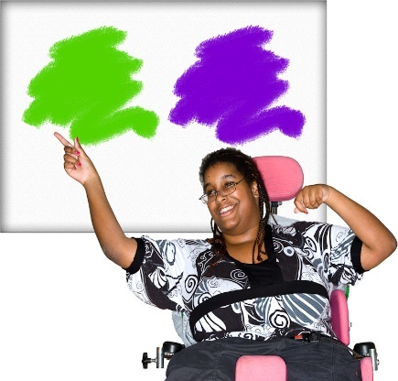
Disabled adults were often treated as if they could not make their own:
choices
decisions.

Deaf survivors were stopped from:
using sign language
taking part in Deaf culture.


Blind survivors were stopped from using Braille.

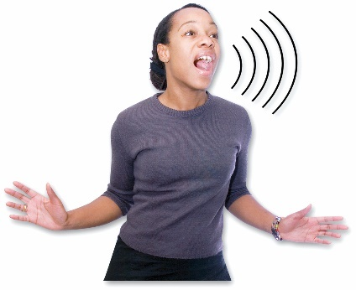
Abusive / uncaring language was used to:
scare people
make people feel bad.

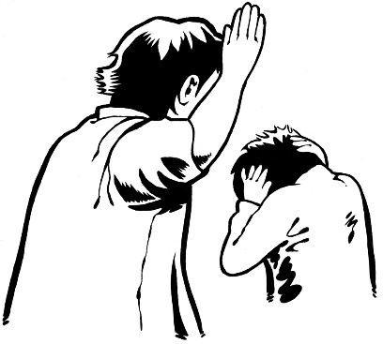
Physical abuse happened a lot in all types of places people were in care.

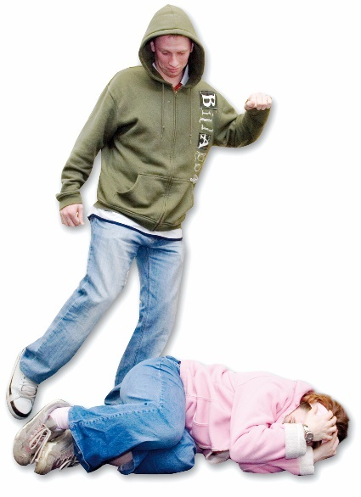
In some cases staff did as much as they could to make things very painful.

They used different things to hurt people with.

They also gave people electric shocks.

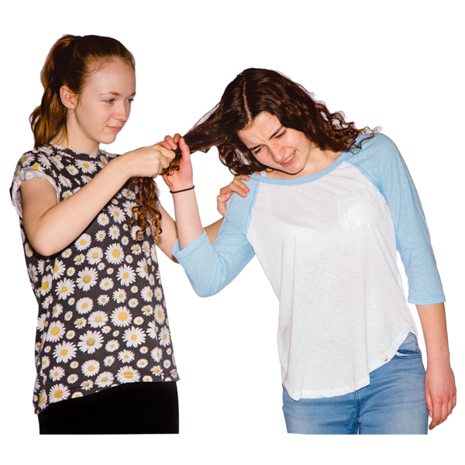
Staff often encouraged children to be violent to each other.

Sexual abuse was common in state / faith-based care places.

Abusers tricked people into trusting them.


They also tricked other staff / people in charge into believing they could be trusted.

This meant that when survivors tried to tell people about the abuse they were not believed.

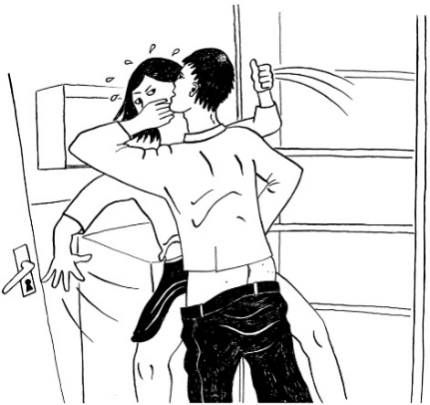
Many survivors were:
sexually assaulted which means hurt in sexual ways
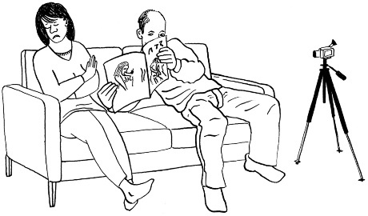
raped which means forced to have sex with someone
made to do sexual things.

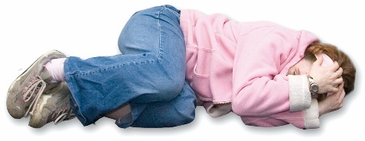
Sexual abuse was used to:
punish people
scare people.

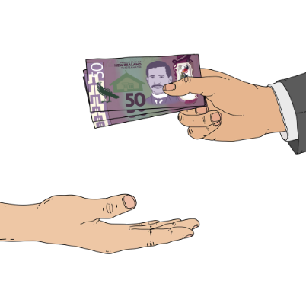
In some cases abusers let other people abuse the survivors in exchange for money.

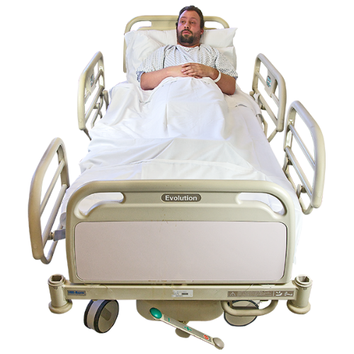
In many care places there was:
medical abuse
medical neglect which is when people are not given the medical treatment they need.


Medical abuse means things like:
people being given the wrong medical treatment
people being given treatment without them agreeing.

This included electric shocks.


Drugs were used to:
punish people
control people.

Solitary confinement was commonly used to:
control behaviour
punish people.
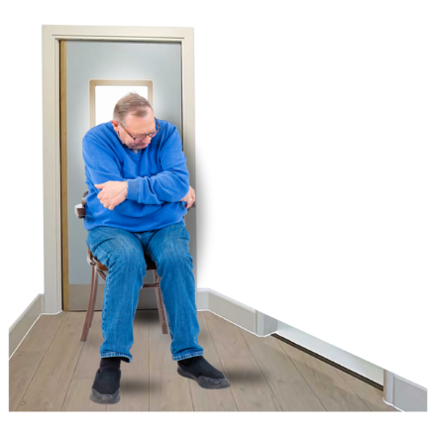

Solitary confinement is when someone is kept alone / away from other people.

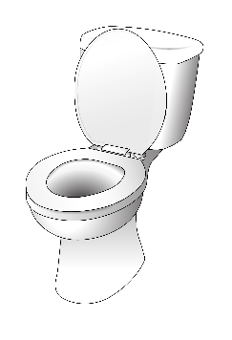
In some places survivors were locked in places with no or not enough access to:

toilets
water.

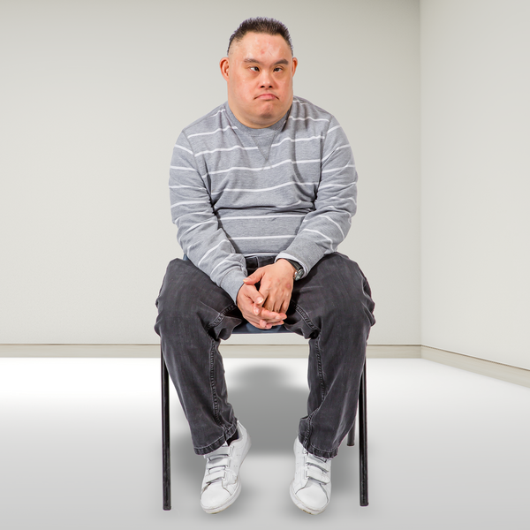
Rooms where people were kept alone were often:
cold
dark
dirty.


Survivors could be held there for a long time.

While they were in solitary confinement some people were abused by staff:
physically
sexually.
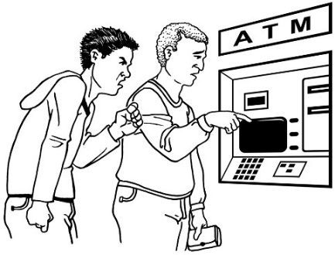

Some survivors were financially abused by their carers.
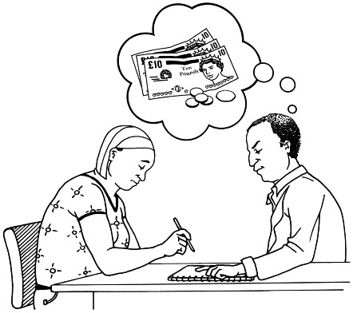
Financial abuse is abuse to do with money like making you:
give the abuser money
spend money in ways you do not want to.


Disabled people were made to work for:
very little pay
no pay.

How did the abuse happen?
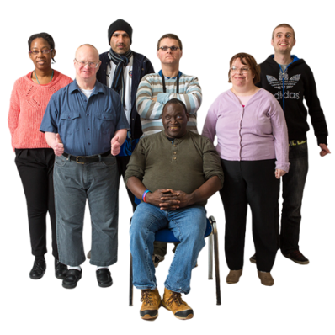

Some of the reasons people were more likely to be in care included:
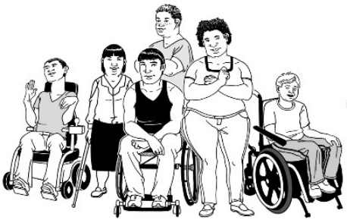
being Deaf
being disabled
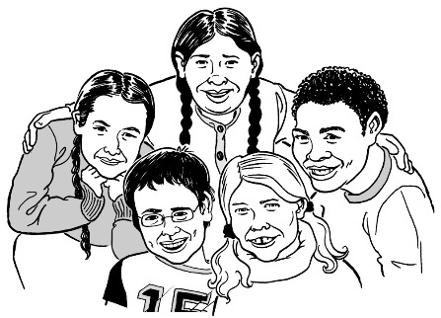
their family not having enough money when they were a child
having bad things happen to them as a child
being Māori
being Pacific

being rainbow
being MVPFAFF+
being takatāpui.
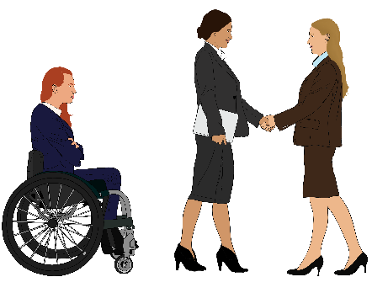
Another reason people were more likely to be in care is experiencing discrimination.

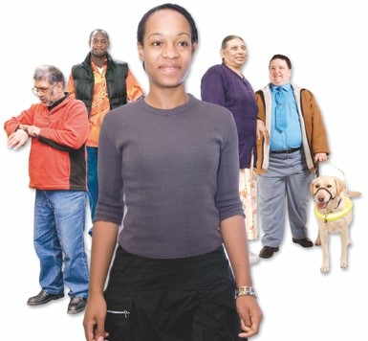
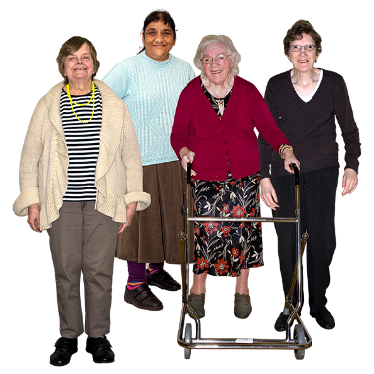
Discrimination is when people are treated unfairly because of things like:
how old they are
if they are a man / woman / someone of another gender
if they are disabled.

Many of these reasons also made it more likely for people to be abused when they were in care.

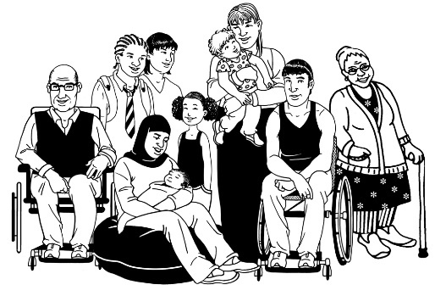
The people who did the abuse / neglect used the power they had over:
children
young people
adults.

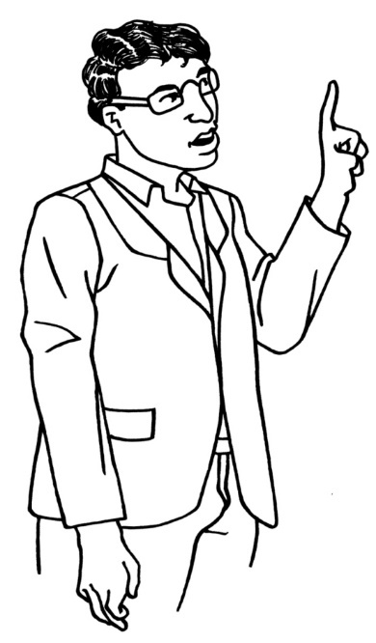
They knew how to use the problems in the care system so they could:
do abuse
not be caught or get into trouble.


There was rarely anything done to abusers – the people who did abuse.

This meant they felt okay doing more or worse abuse.
Abusers were often people the community thought well of.

Many of the systems that were set up let abusers:
do abuse
get away with it.

Society discriminates against people who are different in lots of ways including:
racism
ableism
sexism – treating people unfairly because of their sex or gender
homophobia – treating rainbow people unfairly.
The way society discriminates against some people meant people in care were thought of as:
not important
less than human.

Discrimination made it easy for the rest of Aotearoa New Zealand to ignore what was happening to people in care.

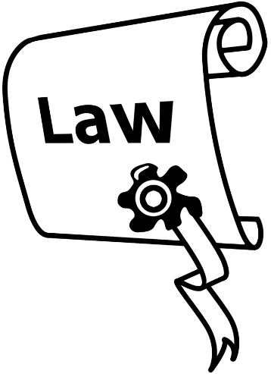
The law said people in Government had to do things to make sure people in care were looked after well.

They did not do these things.

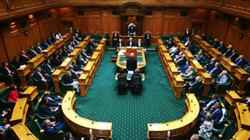
The Government and leaders of faith-based institutions:
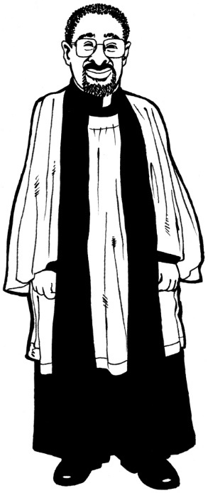
knew about the abuse or should have known about the abuse
were meant to:
- keep people in care safe
- deal with abusers.

They did not do what they were meant to.
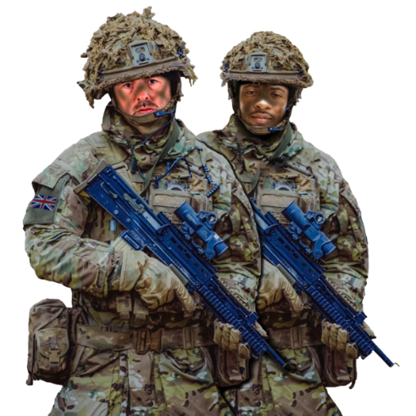

People from military backgrounds were thought to be right to care for people.

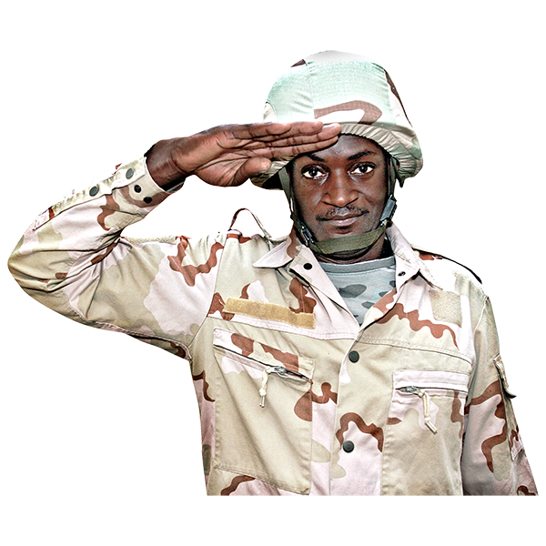
Military means the armed forces like the:
Army
Navy.


These people brought with them the idea that they were there to control people with:
punishment
violence.


Some people who worked in care saw abuse happen so much it seemed normal.

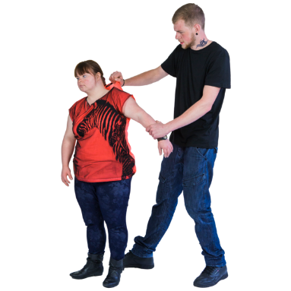
Then they abused people as well.

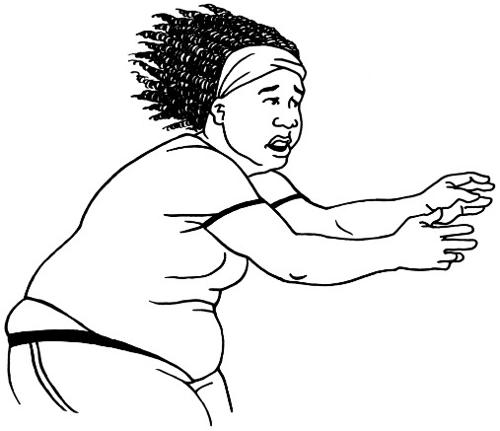
Other people who worked in care:
were too scared to do something
felt there was nothing they could do

lost their jobs when they tried to do something
were told to stop talking about abuse.

There were some specific reasons faith-based institutions had abuse.

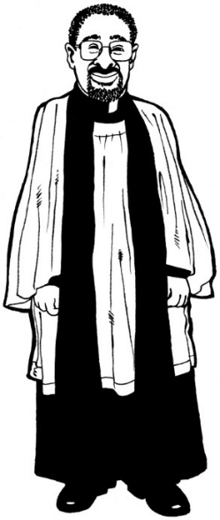
People thought religious leaders were the ones who:
knew what was right / good
could be trusted.

Religious beliefs were often used to:
say abuse / neglect was okay
stop survivors saying anything.

Religious groups often:
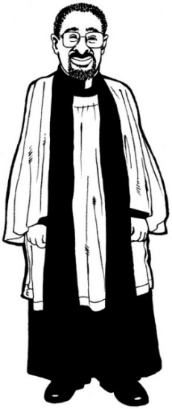
had strong ideas about who was in charge of who
had people make decisions in private.

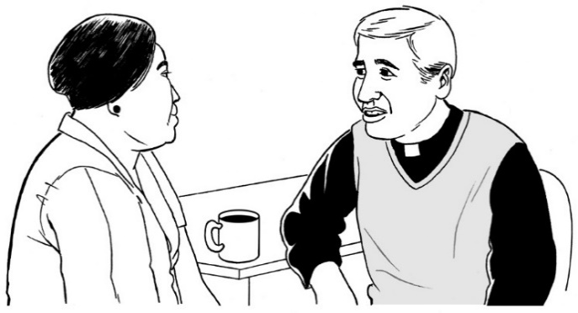
Some religious groups said survivors had to do lots of things like forgive their abusers.

Abusers just had to repent for doing abuse which is like saying sorry to God.
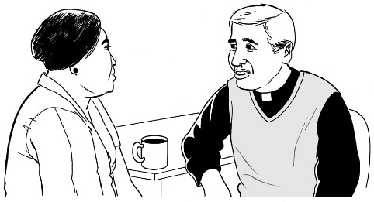
Abuse was often just treated as a sin.

A sin is:
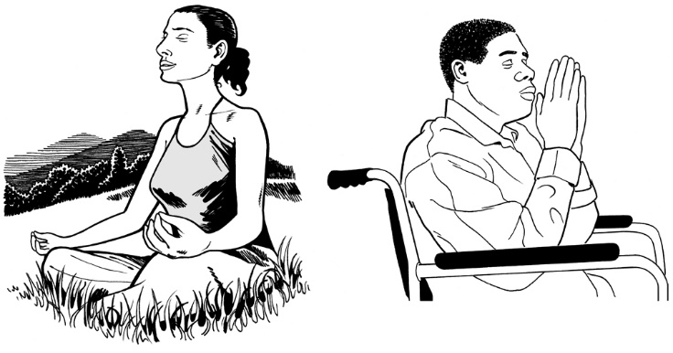
something bad you do
that you can fix by saying sorry to God.

Workers were not well:
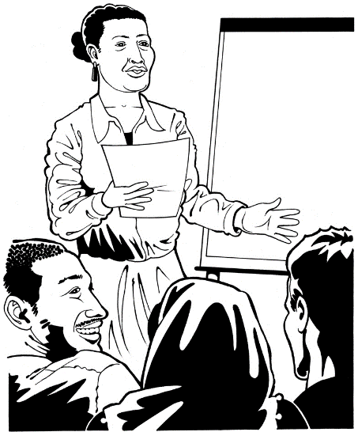
checked
trained
managed.

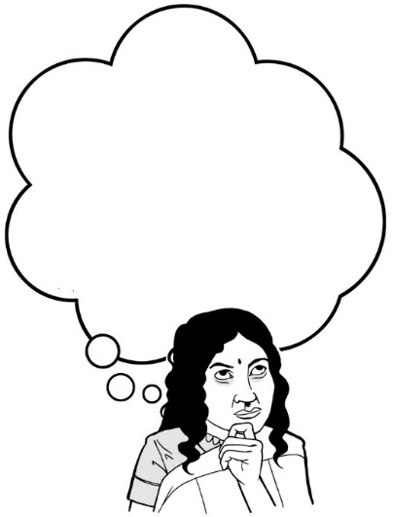
Some people making decisions about care had:
little understanding
not many connections with:
- people in care
- their communities.

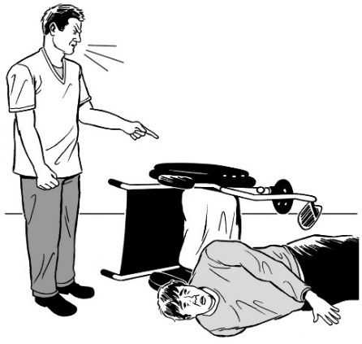
When there were not enough staff it meant:
more neglect happened
abusers could do more abuse.
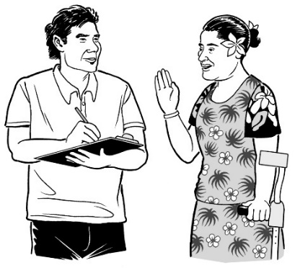

Only some places had ways of dealing with complaints.

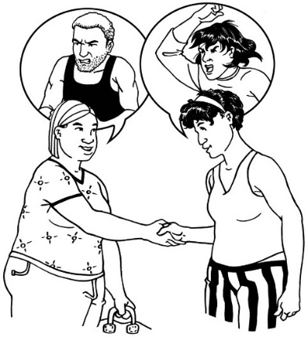
A complaint is when you tell someone:
what is wrong
that something needs to change.

Often when people complained:
they were not believed
nothing was done.

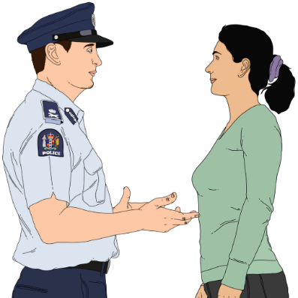
Only a few complaints were sent to authorities like the police.

Many abusers were just moved to other places.

They kept abusing people in the new places.

There was not enough independent oversight of care.

Independent oversight means other organisations watching how care is going.
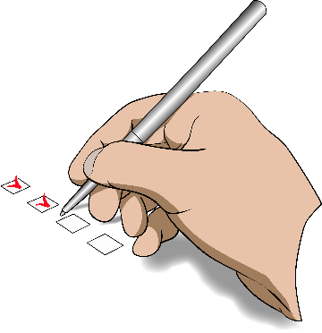

All the reasons abuse / neglect happened worked together.

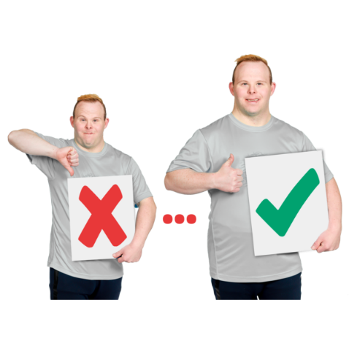
This meant neglect / abuse kept happening for many years.


In more recent years there have been some changes to do things better.

But most of the problems that led to abuse / neglect are still there.

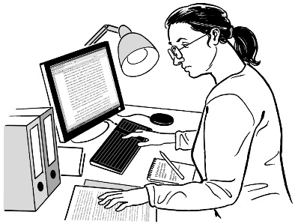
The Commission looked into things that happened from 1950 to 1999.

This is because in 2021 the Government changed the rules about the Commission.


The new rules said the Commission could not look at anything that happened from the year 2000 or later.

Survivors also told the Commission that lots of the problems from then are still problems today.

How has the abuse affected survivors?

Abuse / neglect in care affected survivors for the rest of their lives.

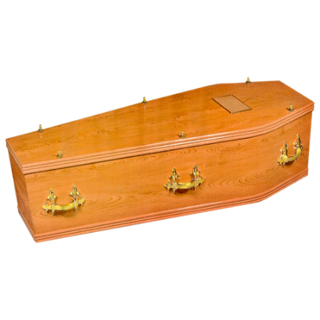
Some people died while they were in care.

Some survivors died by suicide later because of what had happened to them in care.
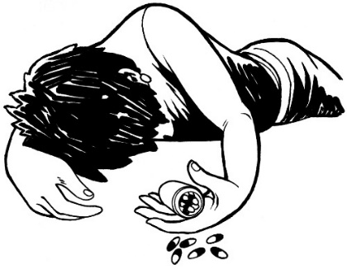

Suicide is when someone decides to kill themself.

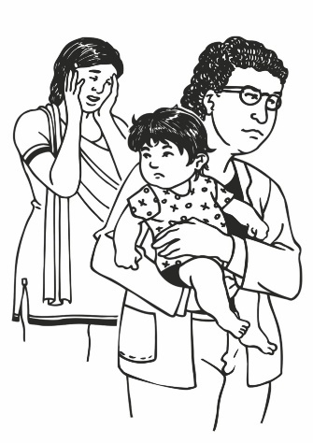
People in care were:
kept away from whānau / family
told no-one loved them.

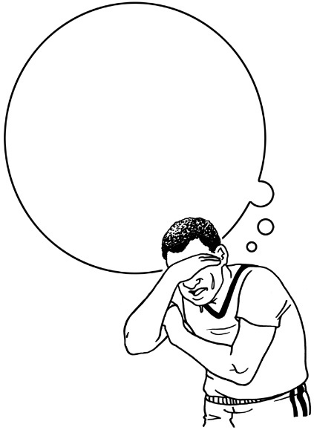
This changed how survivors:
think of themselves
think of others
understand the world.

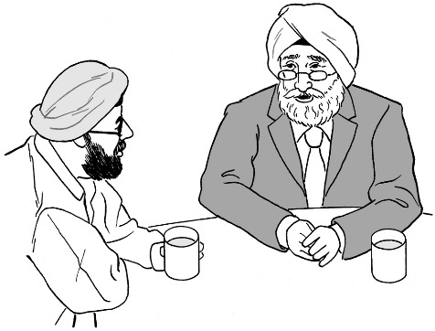
It has made it harder for them to:
make good relationships
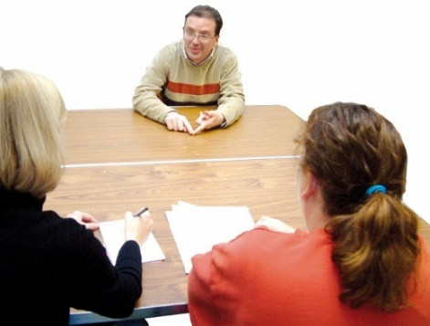
find jobs
keep jobs
do all the things they could have done.
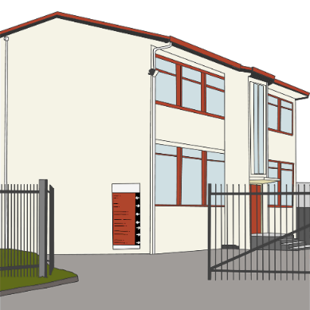
Many survivors did not get an education because they:
were not sent to school

were not given the support they needed to learn
could not learn because they were being abused / neglected.

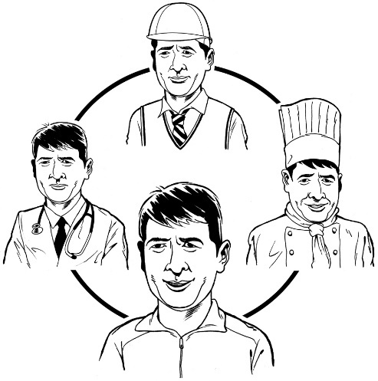
Not getting an education has meant they have:
found it hard to get jobs
not been able to do the kinds of jobs they might have done if they had a good education.

There was so much violence in care that some survivors felt like it was normal.

Some survivors abused other people.

For many survivors their time in care led to them:
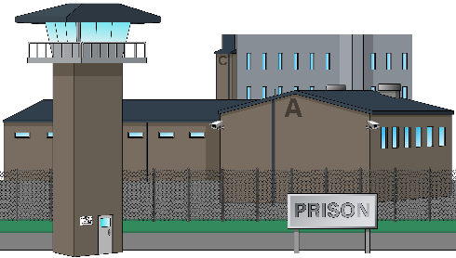
doing crime
ending up in prison.

Some survivors became trapped in care.

Some of them are still in institutions now.

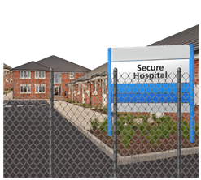
Some survivors went from prison to psychiatric care.

Psychiatric means medicine to do with mental distress / your mind.
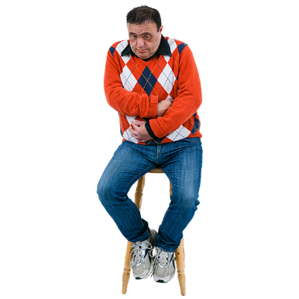
Many survivors have health conditions because of their time in care.

These may be because:
they were hurt by abuse

they did not get proper medical treatment
they were given medical treatment that was wrong for them.

Some people died in care because of not being given medical care.

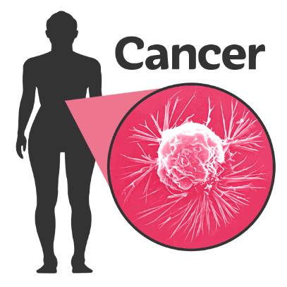
Trauma makes it more likely for people to have medical conditions like:
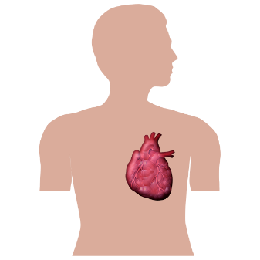
cancer
heart disease
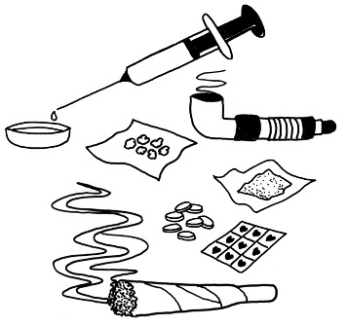
addiction which is when you find it hard to stop using things like drugs or alcohol
mental health conditions like depression.

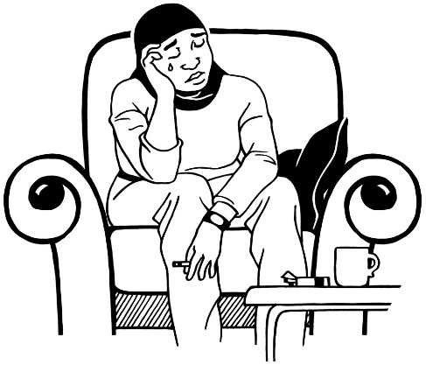
Trauma is the effects bad things like abuse have on people.

Trauma can last a very long time.

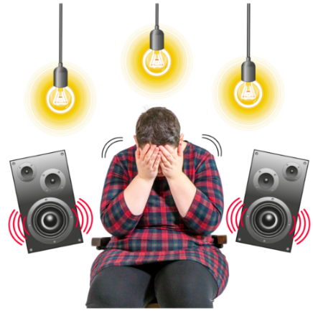
Survivors are triggered by things like:
sounds
tastes
smells.

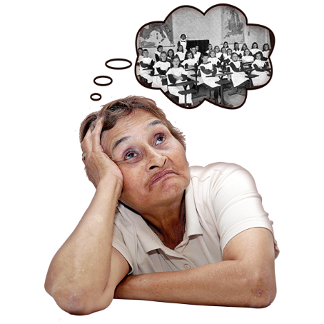
Triggered means they:
are reminded of the abuse
may feel like the abuse is still happening.

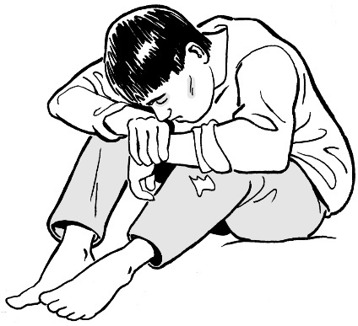
Many survivors:
feel whākamā / shame
do not feel good about themselves.

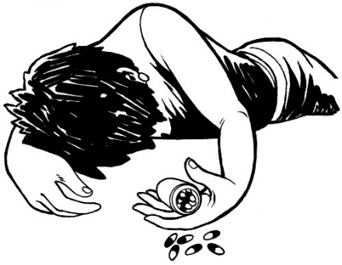
This has meant some survivors have:
hurt themselves
wanted to kill themselves
tried to kill themselves
died by suicide.

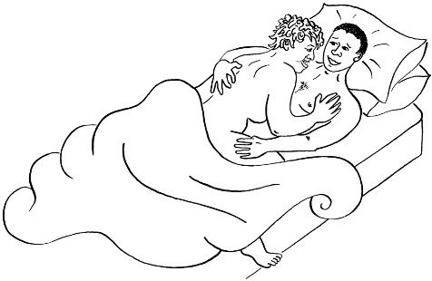
For some survivors sexual abuse changed their ideas of what sex is like.

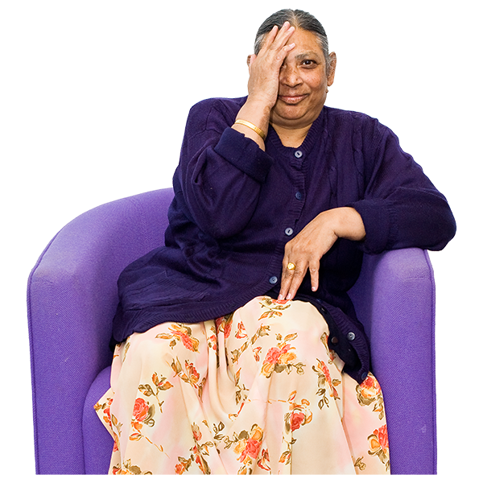
They often have difficulty having good sexual relationships.

Many have decided not to have sex.

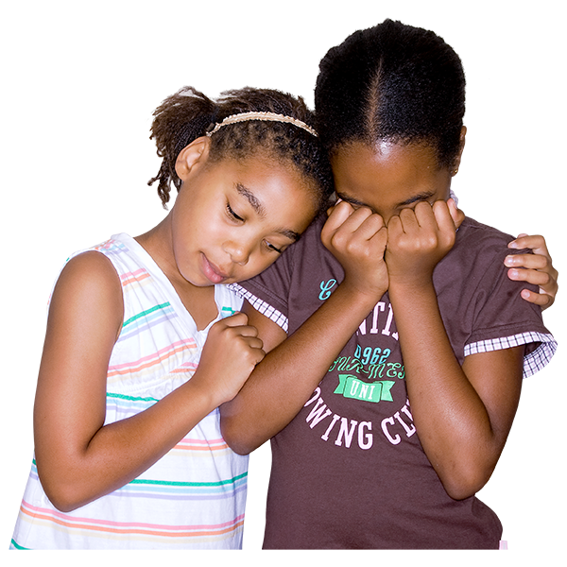
Some people in care were kept away from their siblings.

Siblings are people who have the same parent or parents as you like:
- brothers
- sisters.


This meant survivors worried a lot about their siblings.

It often meant they did not see each other again.
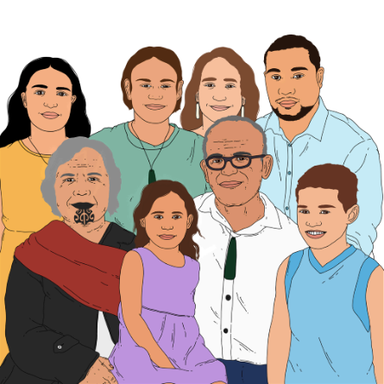

Abuse and neglect in care also affected whānau.

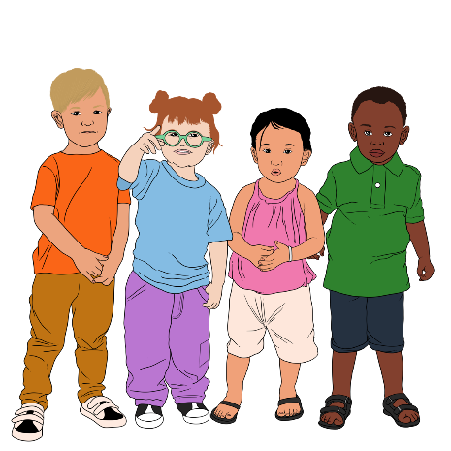
This included new generations like:
children
grandchildren.

Survivors talked about:
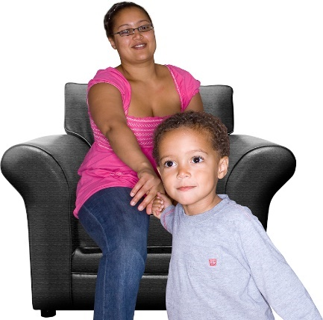
not knowing how to parent
finding it hard to form close relationships with their children.

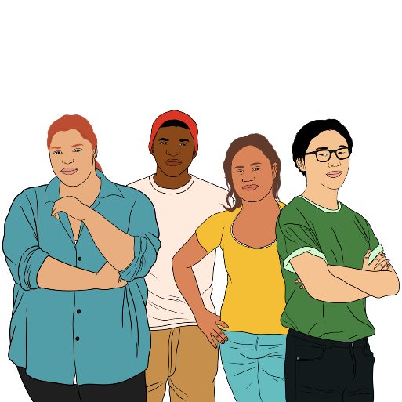
Children of survivors told the Commission about growing up with a parent who experienced abuse / neglect in care.

They said it damaged their own childhoods.

How does abuse affect groups of people?

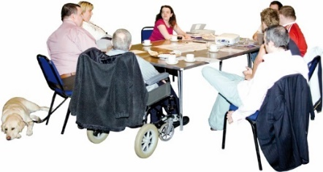
Abuse affects people who were abused.

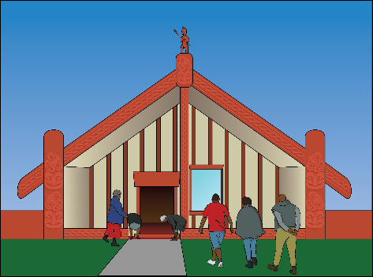
Abuse also affects wider groups of people like:
Māori
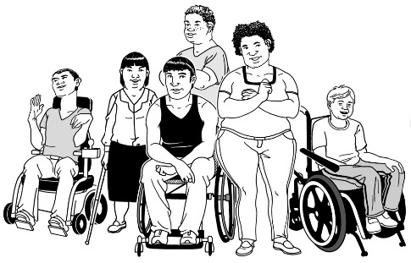
Deaf people
disabled people.

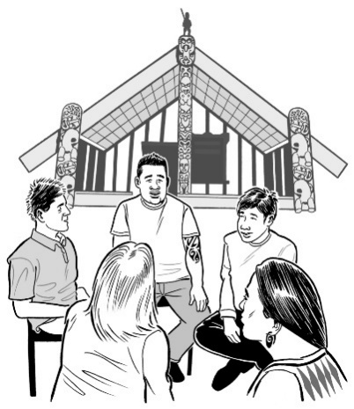
Māori have been affected a lot by abuse in care.

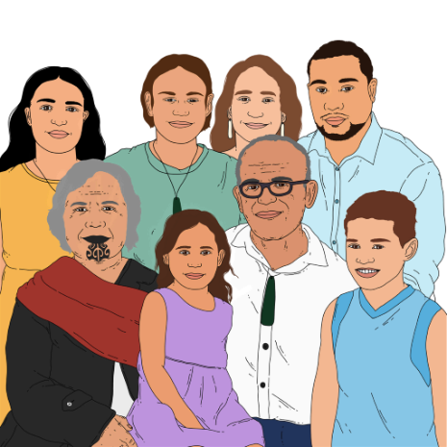
Tamariki / children have been taken away from their:
whānau / families
hapū
iwi.

This has meant they have been deprived of their:
reo / language
tikanga
mātauranga Māori.

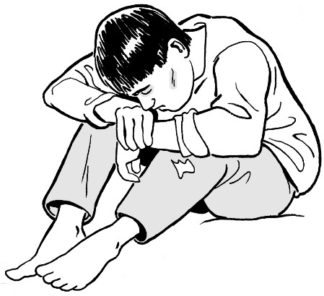
Deprived means they have:
had it taken away from them
not been allowed to have it.

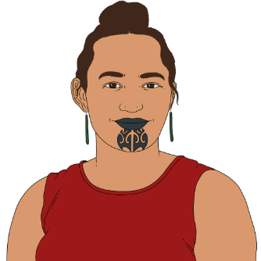
People who would have been leaders for Māori have not been able to do that.

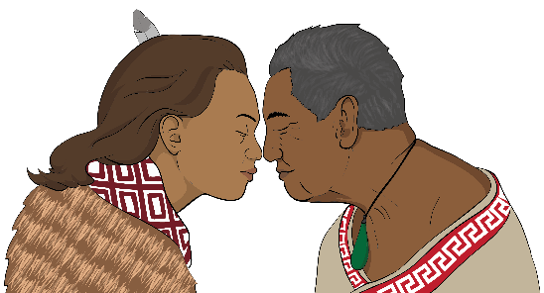
This means Māori have not been able to have the leaders they should have had.

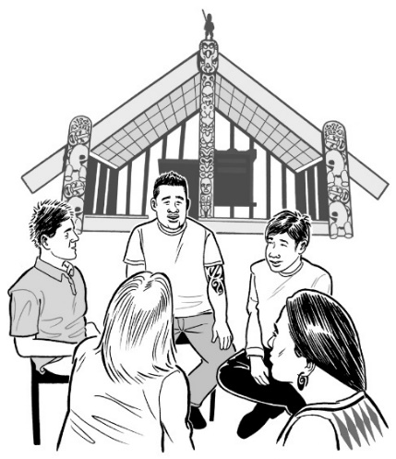
Tino rangatiratanga is an important idea for Māori.

It means groups of people getting to:
make their own decisions
decide how they will run things.

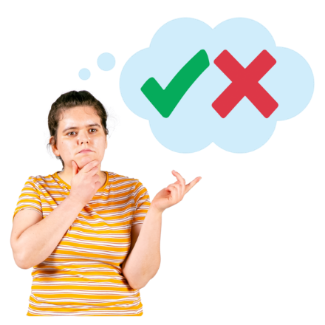
Having tino rangatiratanga over their kāinga / home means Māori getting to make their own decisions about what happens in their homes.

Tino rangatiratanga over their kāinga is one of the most important roles for:
whānau

hapū
iwi.

When Māori were put into care it stopped these groups of people having tino rangatiratanga over their kāinga.

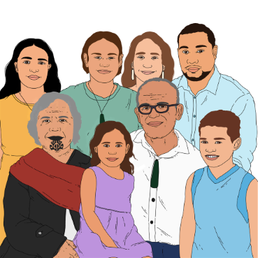
It stopped them from being able to:
care for their people
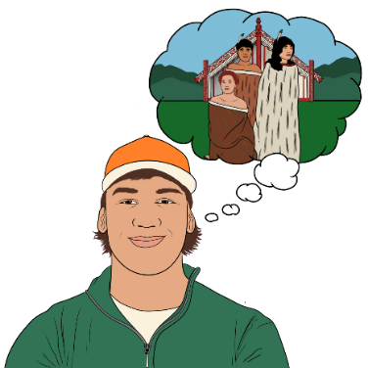
make rules about the lives of their people
pass on mātauranga Māori.

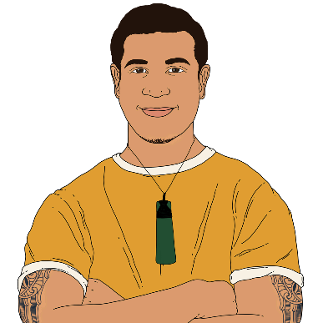
Putting people in care was dehumanising in a particular way for:
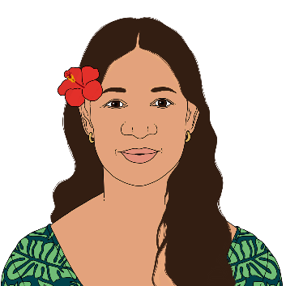
Māori
Pacific peoples.

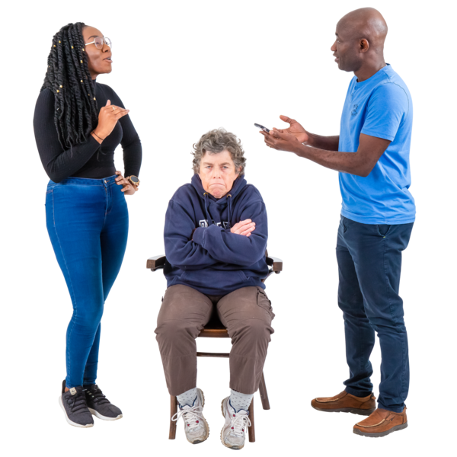
Dehumanising means treating people as if they are not human.

This is because collective identity is very important for:
Māori
Pacific people.

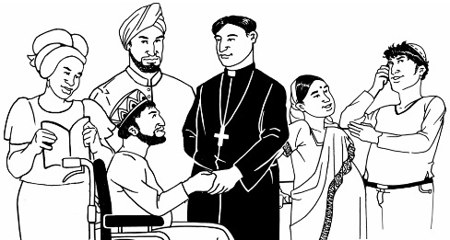
Collective identity is about how you see yourself as being part of a:
culture
group.

Being put in care stopped people having their collective identity.

For many people this was both:
culturally abusive
spiritually abusive.

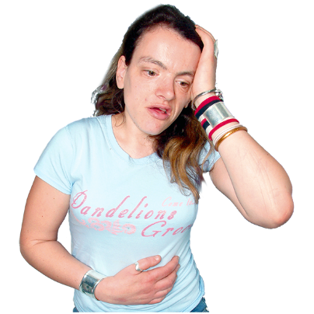
Trauma from abuse has led to much larger problems like:
health issues
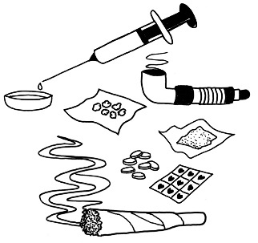
mental distress
harm from using things like drugs
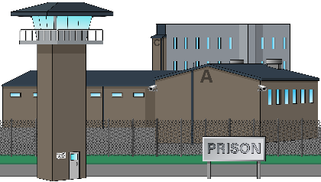
lots of people in prison
people hurting family members
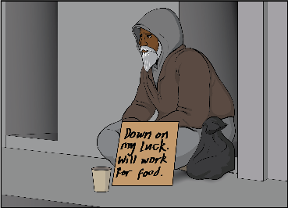
people not having jobs
people not having places to live
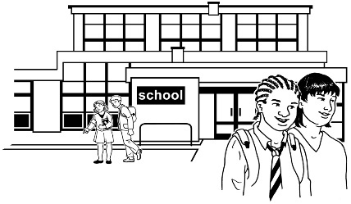
not getting a good education.

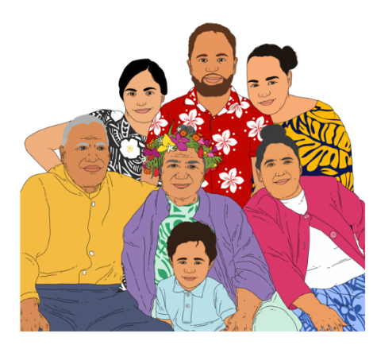
Many Pacific survivors lost their links to their:
kainga / family
culture
language.
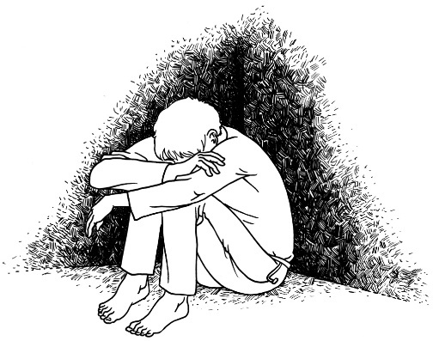

Survivors spoke about the devastation caused by being disconnected from their culture.

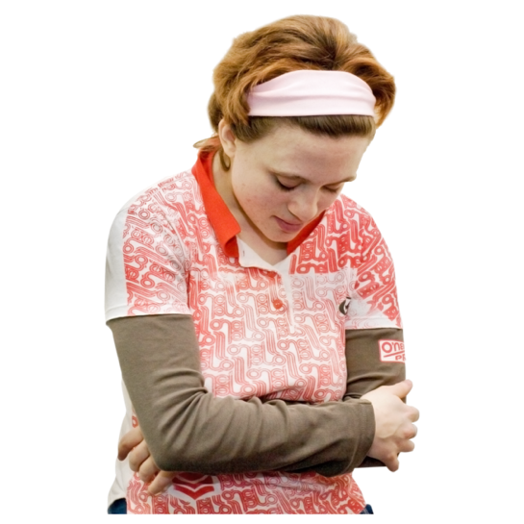
Devastation means important things have been destroyed.

When you feel devastated you may feel:
- that you have nothing
- that there is no way to make things better.
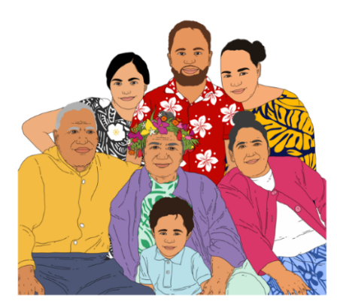
This caused harm to the vā.

The vā is a Pacific idea of something between us that joins everything together.

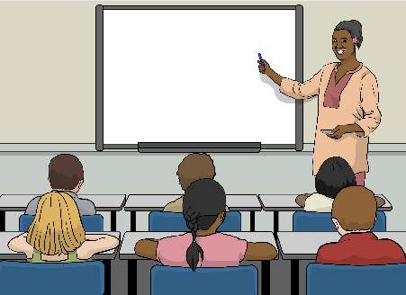
It also impacted on fakatupuolamoui which is a way Pacific people talk about being able to live a really good life.

There was also an impact on many
Deaf survivors
disabled survivors
survivors with mental distress.

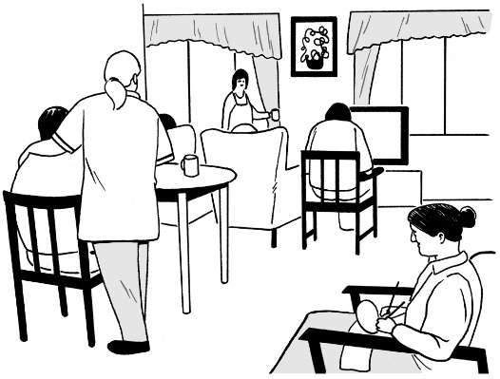
When they were in care they were often kept away from:
their communities
their whānau / family.

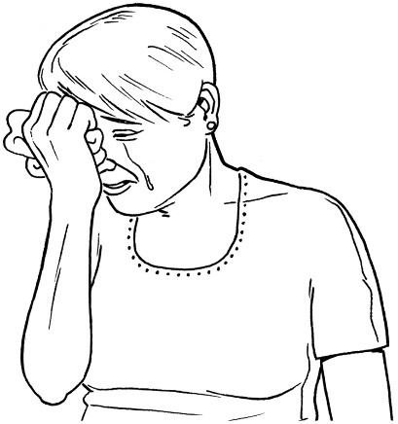
This has caused them:
very bad pain
harm to their lives.

Being put in care meant people found it hard to live outside institutions.

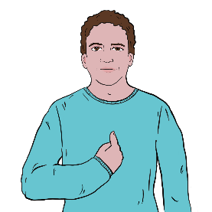
Deaf / disabled people were stopped from having:
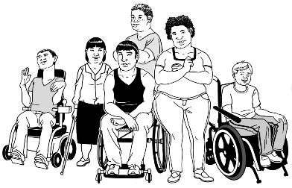
personhood which is the sense of being a person
their culture
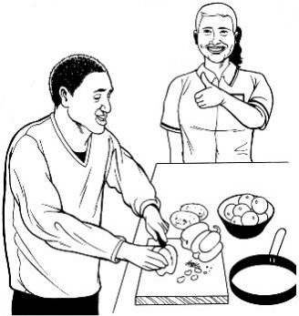
the chance to learn the things they needed to live good lives in the community.

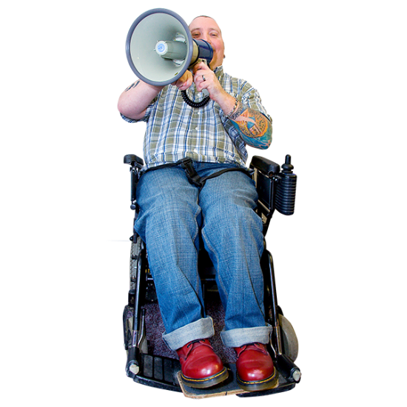
These people lost the chance to be leaders.

All communities lost the chance to have them as leaders.

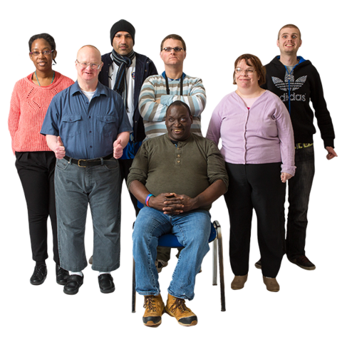
Deaf people in care were not allowed to know:
about Deaf culture / communities
that they could be part of Deaf culture / communities.
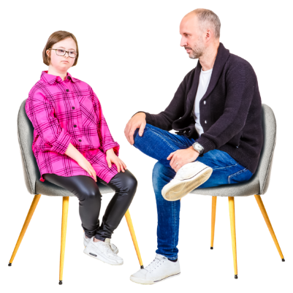

They were forced to talk / use speech to communicate.


They were physically abused for using sign language.

They were not able to learn much sign language.

This meant they were not:
confident using sign language
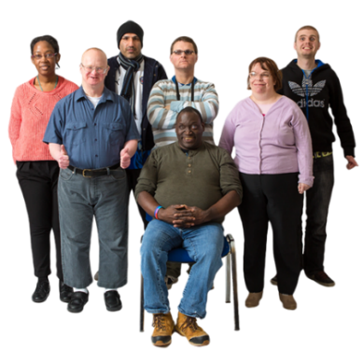
able to access their own culture
able to talk to their own community leaders.


Other groups that were harmed are the communities of:
takatāpui survivors
rainbow survivors
MVPFAFF+ survivors
gender diverse survivors
transgender survivors.

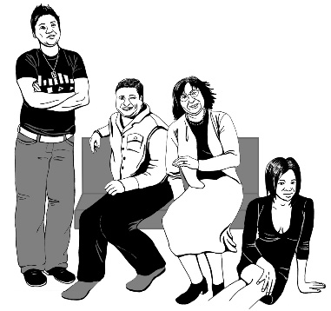
Transgender people are people who have a different gender to the one people thought they had when they were born.
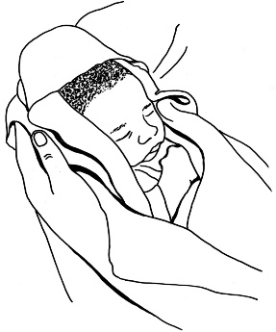

For example people might think someone is a boy when they are a baby.

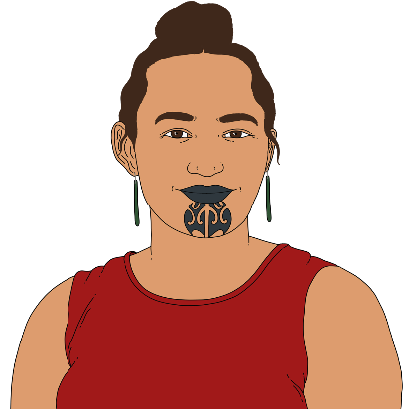
When they get older the person knows they are a girl / woman.

They / their communities experienced:
abuse
harm
hate.

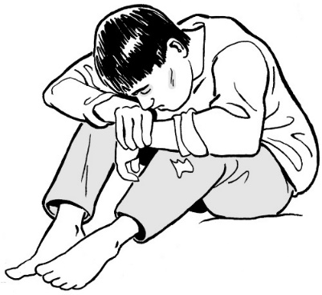
This led to:
mental distress
PTSD which is an illness that comes from trauma
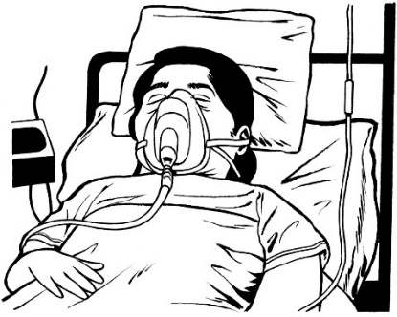
people wanting to die from suicide
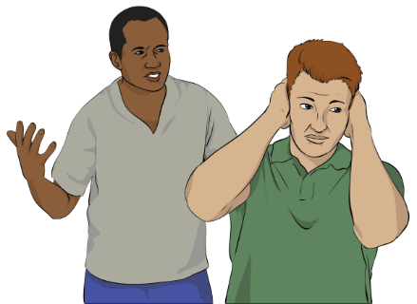
people having poor health with their bodies
relationships not being good.

The abuse meant people could not be themselves.

It also stopped communities doing as well as they could have.

Some survivors experienced trauma when they left their faith / religion because of abuse / neglect.

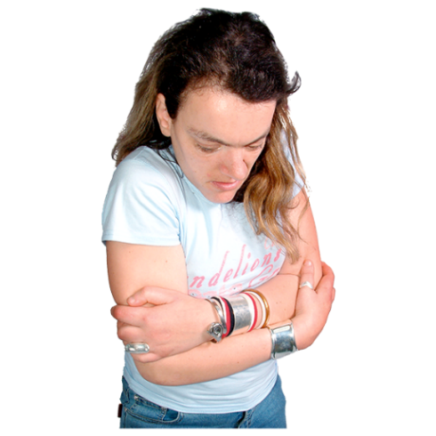
For some survivors leaving their church meant losing their
family
friends
job.

Some survivors chose to leave their churches.

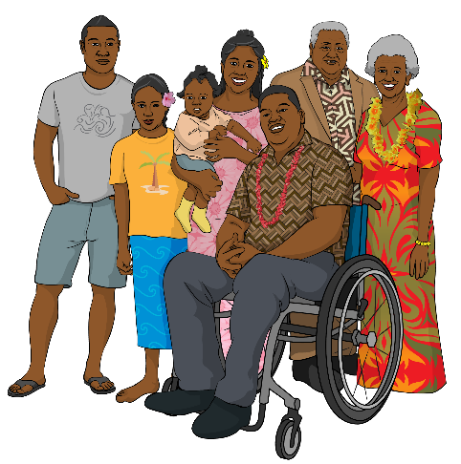
Others were made to leave.

Some people were not able to see their family again after they left.

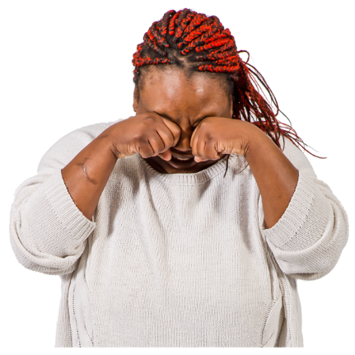
The result of leaving churches was
emotionally devastating.

There was a loss of
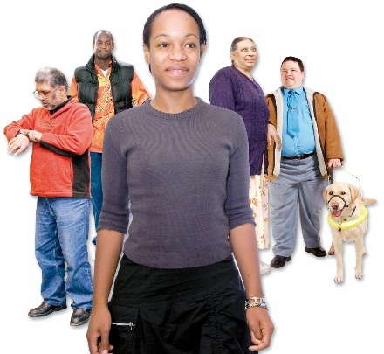
identity
community
money.

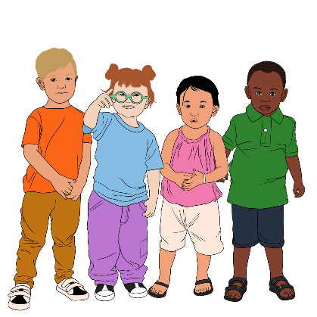
Many survivors have worked hard to make things better for:
their tamariki / children
other younger people / people who are not yet born.

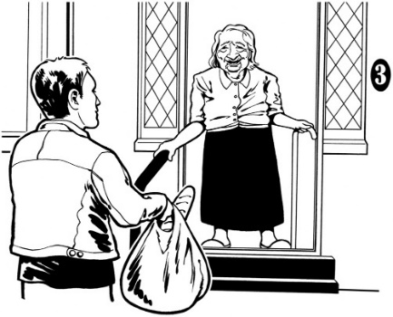
Some survivors have found ways to feel better by:
supporting others
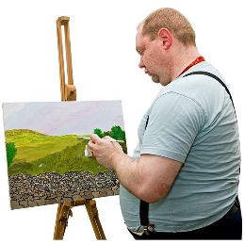
being part of:
- arts

- sport
- other community activities.

The cost of abuse

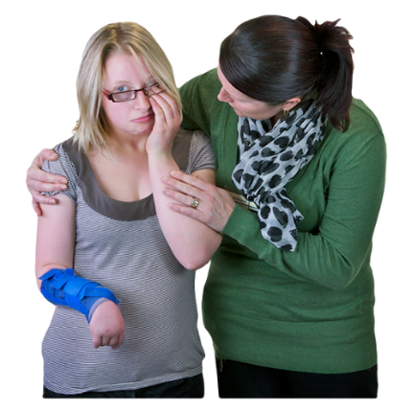
Abuse has caused huge harm to:
people
communities.

Abuse has also cost a lot of money.


The total cost of abuse in care between 1950 and 2019 is probably between:
almost 1 hundred billion dollars
and
a bit over 2 hundred billion dollars.

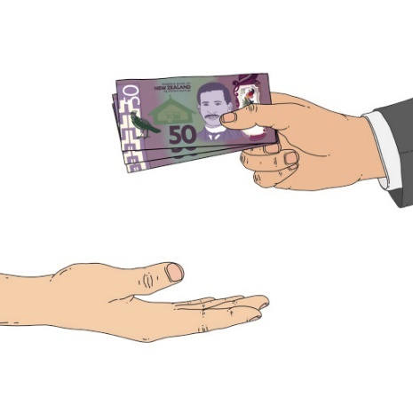
Less than 50 billion of this money was paid in taxes.

Most of it is money survivors have had to pay themselves.

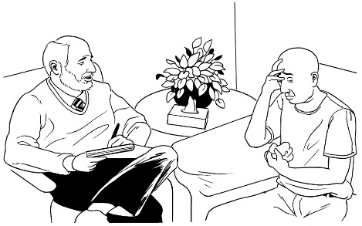
Abuse costs survivors lots of money because they:
need to pay for things like support or healthcare related to the abuse
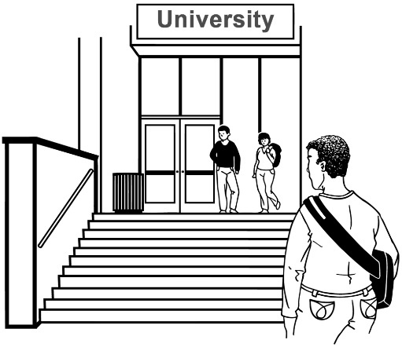
cannot earn as much money as other people because:
- they did not get a good education
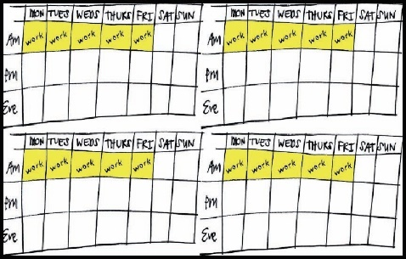
- they cannot work as much because of the trauma.

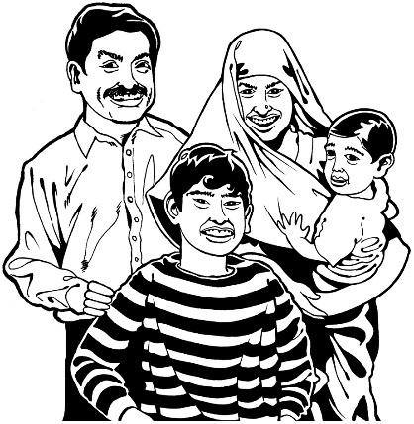
Abuse / neglect in care has had a financial effect on:
survivors
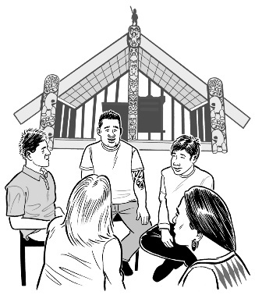
families
hapū
iwi
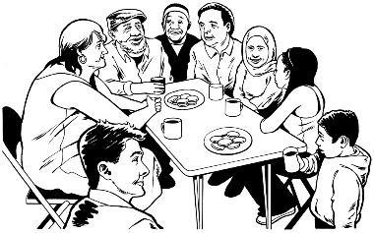
communities
society / all of us.

Financial means to do with money.


The harm it has caused is still happening.

It has contributed to social inequities.

Social inequities are when things are unfair because:
some groups of people have more money than others
the people without much money find it harder to get important things like:
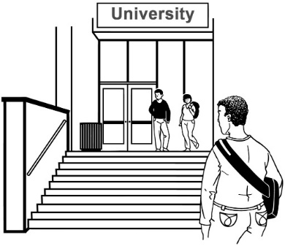
- warm housing
- a good education.

Not listening to survivors made things worse.


Survivors spent many years calling for justice.

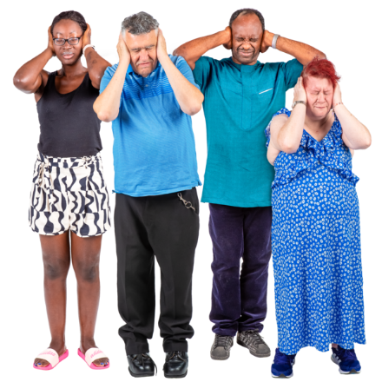
Surivivors were:
not listened to
not believed
made to stop speaking out.

What happened to them was treated as being not important.

When survivors did get anything they were usually still not treated well.
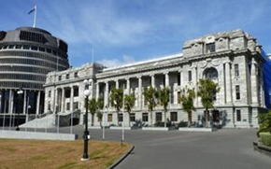

Government leaders hid what was happening.


Government leaders then worked against survivors to:
stop survivors costing the Government money
stop themselves looking bad.


Working against survivors cost:
- time
- energy spent on that work
- money paid in taxes.

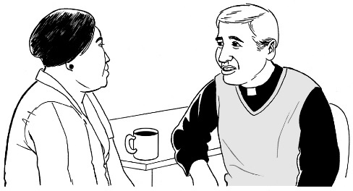
Religious leaders also tried to hide abuse by:
moving abusers to other places
saying the abuse was not their fault.

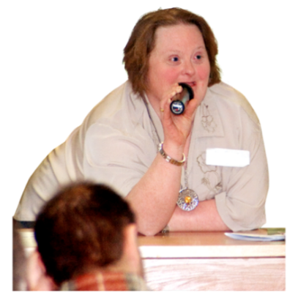
Survivors were right to say there should be a Commission.

The way survivors have been treated has been awful.


It needs to stop.

This information has been written by the Royal Commission of Inquiry into Abuse in Care.

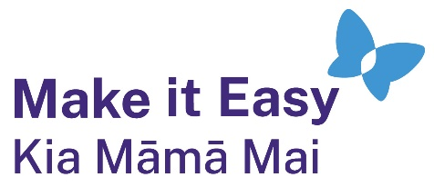
It has been translated into Easy Read by the Make it Easy Kia Māmā Mai service of People First New Zealand Ngā Tāngata Tuatahi.
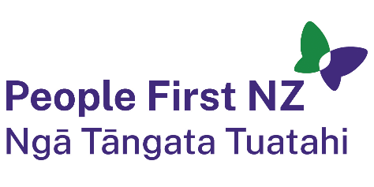
The ideas in this document are not the ideas of People First New Zealand Ngā Tāngata Tuatahi.
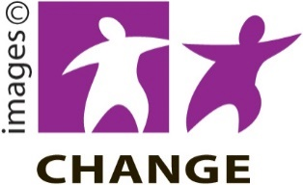
Make it Easy uses images from:

- Changepeople.org


            - Photosymbols.com



- SGC Image Works
- Huriana Kopeke-Te Aho
- T. Wood.

All images used in this Easy Read document are subject to copyright rules and cannot be used without permission.

