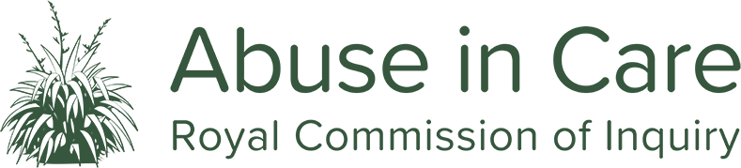
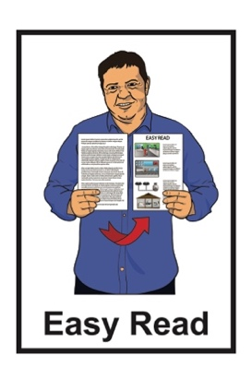

Whanaketia – Through pain and trauma, from darkness to light
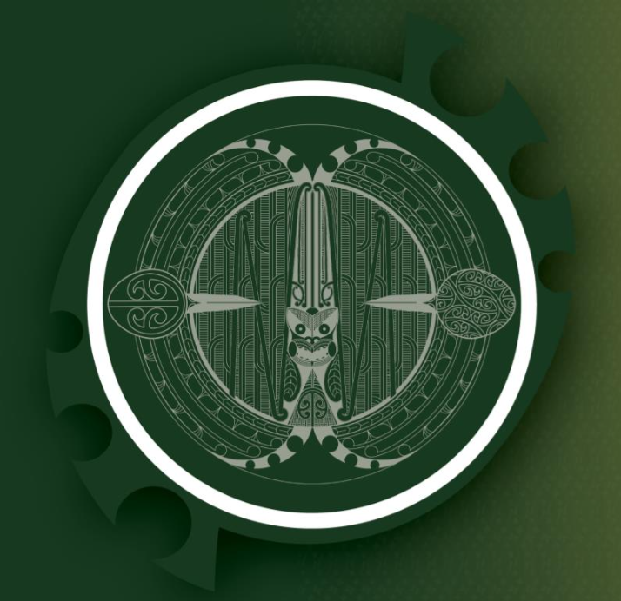

Easy Read summary – Part 2
Published: October 2024

Before you start


This Easy Read document is about a report written by the Royal Commission of Inquiry into Abuse in Care.


Some of the information and pictures used in this document are very upsetting.

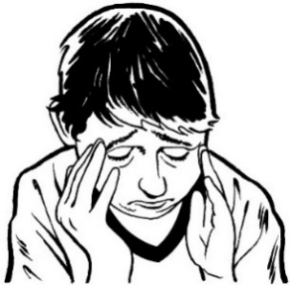
This document is about people being badly hurt by people who were meant to look after them.

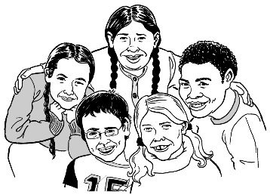
The people who were hurt include:
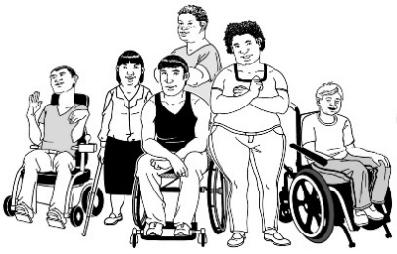
children / young people
disabled people
people who experience mental distress.
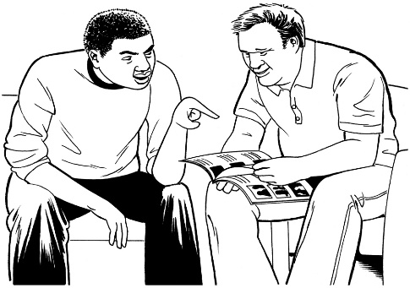
Before you read this document you might want to make sure you:
- are in a safe place
- have people who can support you.

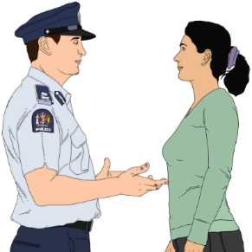
If you do not feel safe call the police on 111.

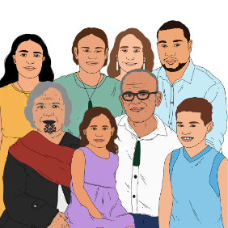
If you are upset after reading this document you can talk to your:
- whānau / family
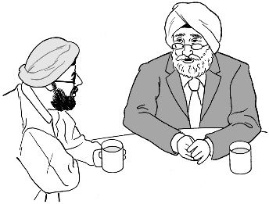
- friends.

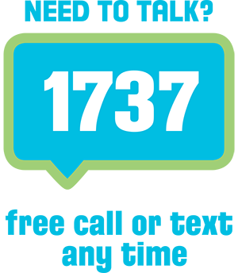
You can also talk to a counsellor at Need to Talk by:
- calling 1737
- texting 1737.



It does not cost any money to call / text 1737.

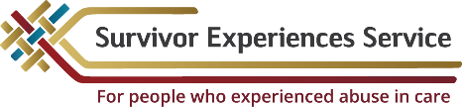
You can also find support through the Survivor Experiences Service.


You can contact the Survivor Experiences Service by:

Phone: 0800 456 090
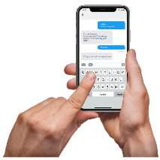
Text: 8328


Email:

contact@survivorexperiences.govt.nz


It does not cost any money to call the Survivors Experiences Service.


You can find information from the Survivor Experience Service about support at:

survivorexperiences.govt.nz/
support-services/


You can find information from the Survivor Experiences Services for disabled survivors at:

survivorexperiences.govt.nz/for-survivors/disabled-survivors/

What you will find in here

Page number:
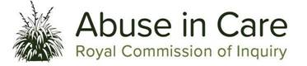
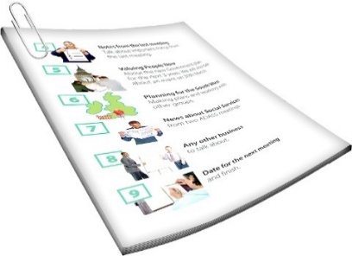
About the Royal Commission of
Inquiry into Abuse in Care 7

What is this document about? 11


A safe and caring future 14


Summary of recommendations 29

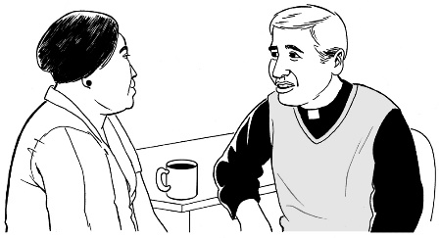
Leaders must make things right 30

Page number:
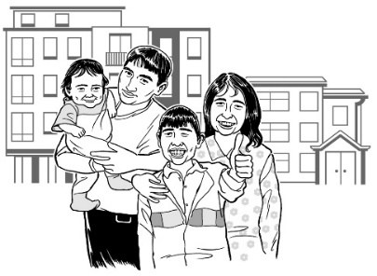

Keeping everyone in care
safe now 33

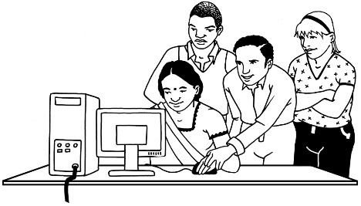
Supporting whānau and
communities 36

About the Royal Commission of Inquiry into Abuse in Care

The Royal Commission of Inquiry into Abuse in Care looked into abuse that happened to people
in care.


The Royal Commission of Inquiry into Abuse in Care is also called the Commission.

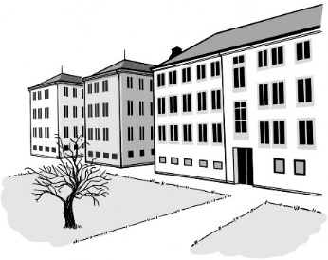
In this document being in care means that the Government or a faith-based institution took responsibility for your care.


Faith-based institutions are organisations that are connected to a religious group or belief.

For example a church is a faith-based organisation.

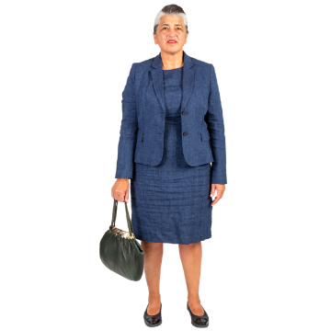
Having responsibility for your care means they are:
in charge of your care

can be blamed if:
- something is done wrong
- they do not do something they should.

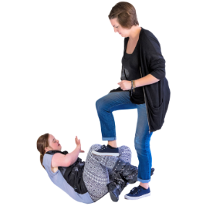
Abuse can be:
- physical – a person kicking or hitting you
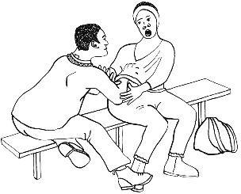
- sexual – a person doing sexual things to you that you do not want them to such as:
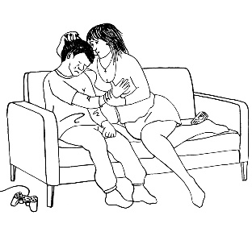
- touching your body or private parts
- kissing you
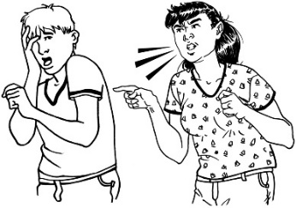
- making you have sex with them – this is called rape
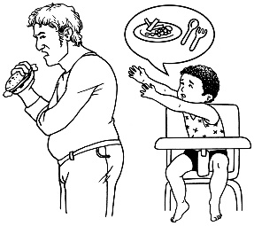
- emotional – a person yelling or saying things to you that are not nice
- neglect – a person not giving you the things or care you need.

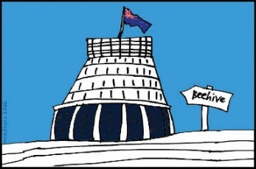
The Commission is not part of the Government.

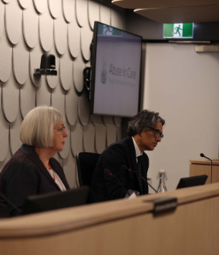
The Government cannot tell the Commission:
how to do its work
what it should find out
what it should say should happen next.


The Commission is not part of any faith-based organisations like churches.

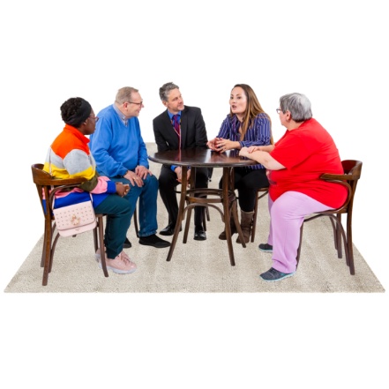
The Commission calls people who have been through abuse in care survivors.

What is this document about?

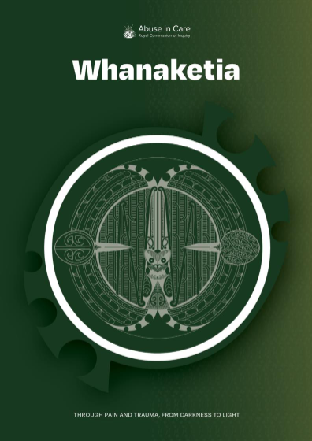
This document is Part 2 of an Easy Read summary of a report called:

Whanaketia – Through pain and trauma, from darkness to light.

A summary is a shorter version of the report.

This is the final report by the Commission.

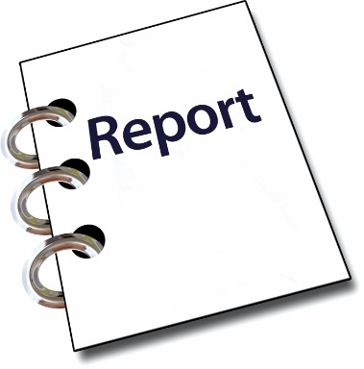
The Commission was set up to look into abuse in care.

Now it has done its work it has made this report.
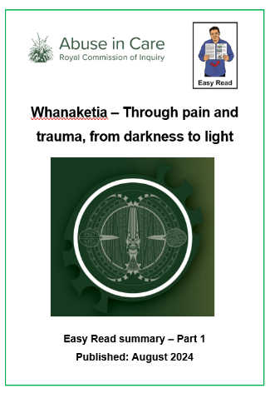

We have split this Easy Read translation into 2 parts.

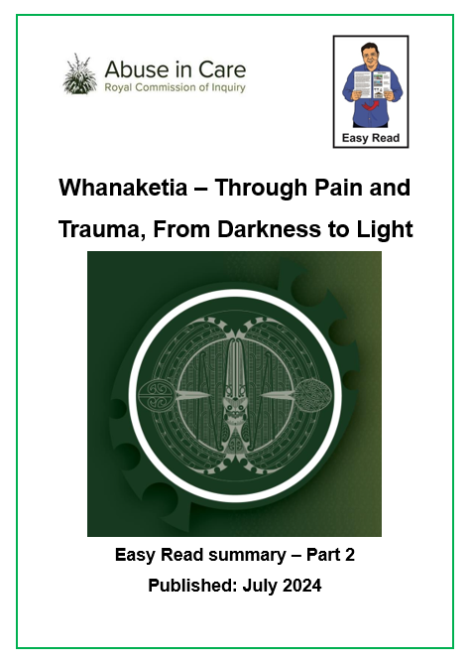

Part 1 is about what the Royal Commission found out.

You can find Part 1 at this website:

www.abuseincare.org.nz
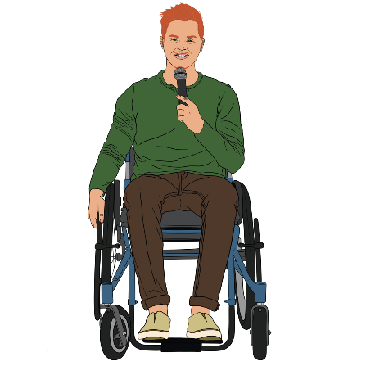

Lots of survivors told the Commission about what happened to them when they were in care.

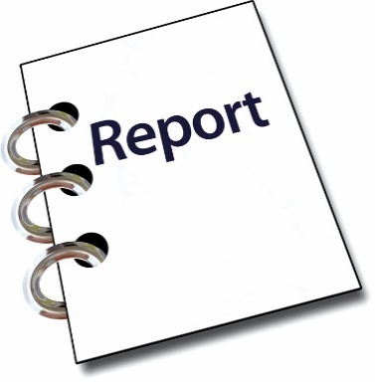
Information from this has been used to make this report.

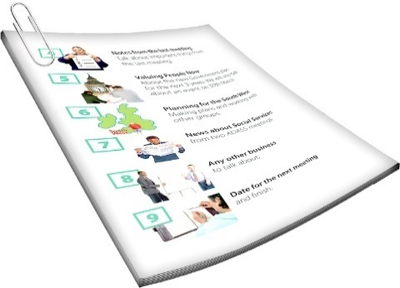
This Easy Read translation is long.


We have chosen not to make it shorter because of how important all the information in it is.

You might want to read it a bit at a time.

A safe and caring future


Survivors shared their
moemoeā / dreams for the future.

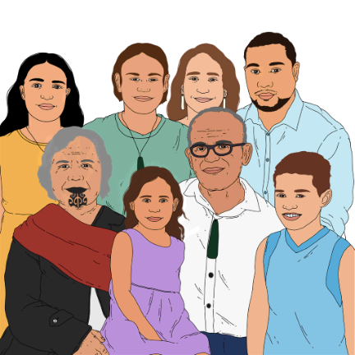
They talked about a future where everyone is:
loved
safe
cared for.

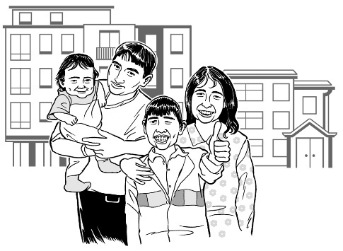
People need to be cared for in a way that supports them to:
do well in life
contribute to society.

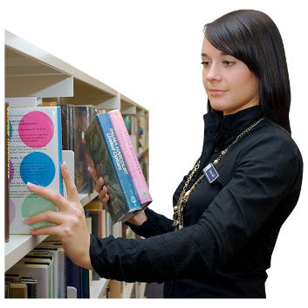
Contributing to society means doing your bit to make things good for everyone.

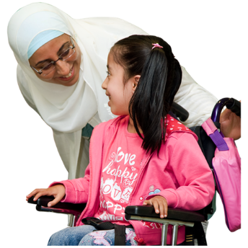
It might mean things like:
supporting other people to:
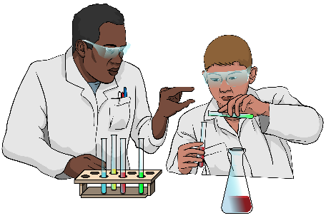
- grow
- learn

doing a job that:
- makes things
- keeps things working well.

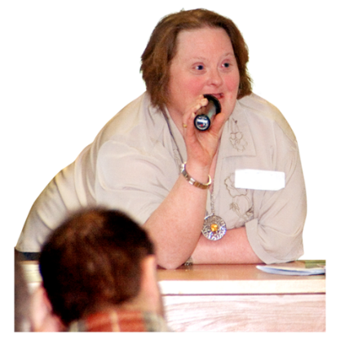

Survivors told the Commission that the care systems need to completely change.

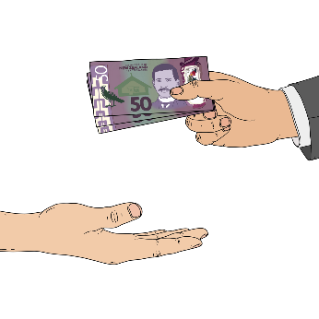
This would mean the Government would need to give communities:
funding / money

control over what happens with care.

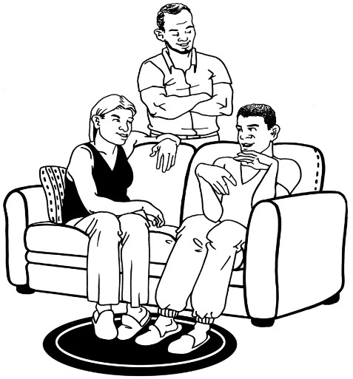
Survivors want every whānau / family supported so they can give loving care themselves.

They must get all the support they need so people needing care can stay with their whānau / family.
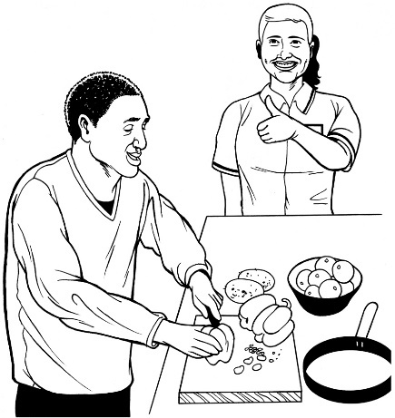

Sometimes care from outside the whānau will be needed.


This outside-whānau care must:
only happen for a short time
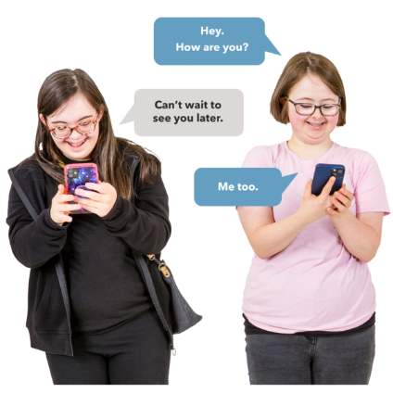
be given by the hapū or community
still have the person needing care keeping in touch with their whānau / family
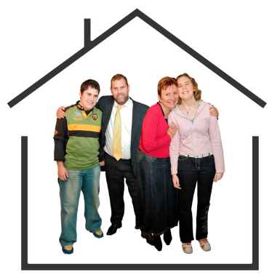
only be used to give whānau time to get support before they come back together.

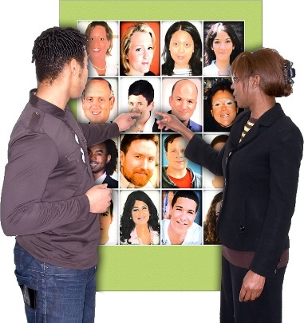
Decisions must still be made by:
the person needing care
their family / whānau.

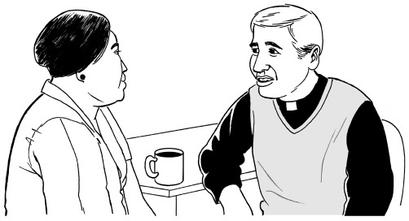
When faith-based organisations do pastoral care they need to have:
national standards
a complaint process that is not hidden.

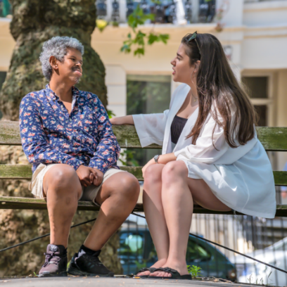
Pastoral care is care to do with your:
feelings
social needs.

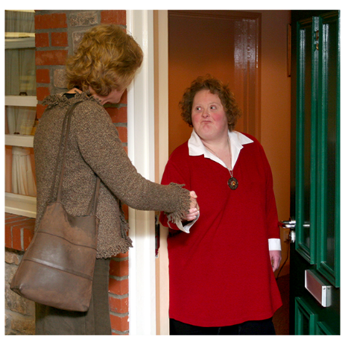
It might include things like:
visiting people
counselling
supporting them to understand their faith.


National standards are like rules or ways of doing things for the whole of Aotearoa New Zealand.

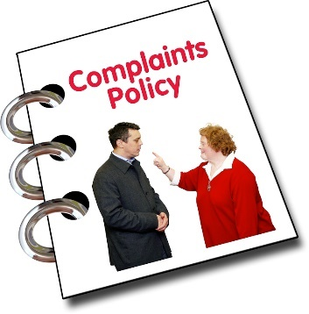
A complaint process is the rules people have agreed to follow when someone says something is wrong.

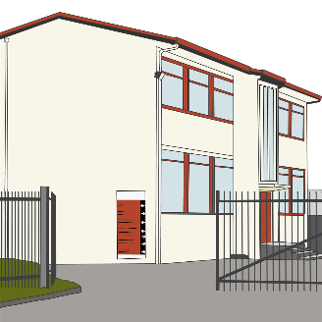
Local schools need to include all students.


All students must have their different needs met.

Everyone must get the support they need.
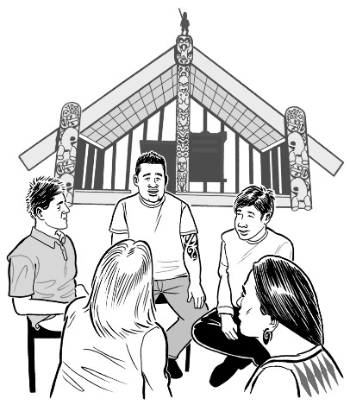

Whānau / hapū / iwi must have their right to tino rangatiratanga over their kāinga.


Having tino rangatiratanga over their kāinga means getting to make their own decisions about what happens in their homes.

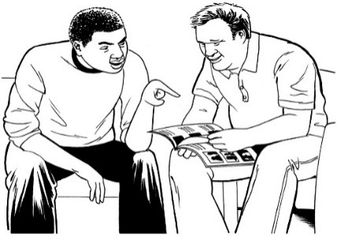
They must have what they need to care for people in their whānau in a way that fits with:
tikanga / Māori ways of doing things
mātauranga.

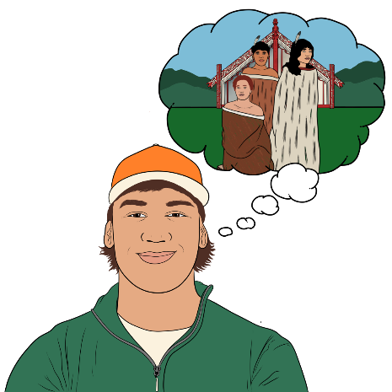
Mātauranga is:
Māori ways of knowing things
information Māori have known for a very long time.

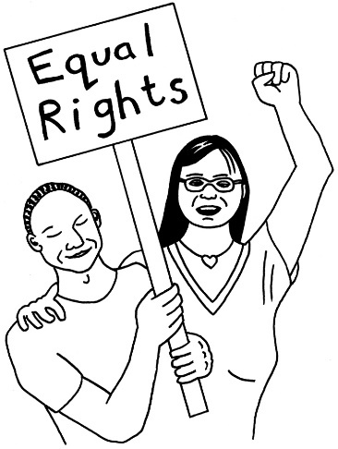
Human rights need to be:
- thought about
- respected
- part of the law.

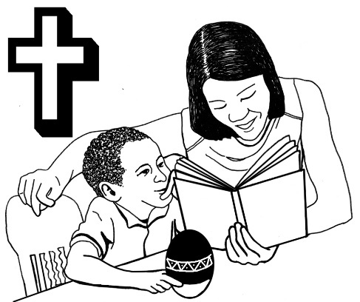
Leaders who do pastoral care in faith-based organisations must:
welcome diversity
have the same diversity as their communities.

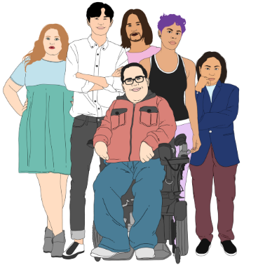
Diversity means the ways everyone is different like being:
different genders
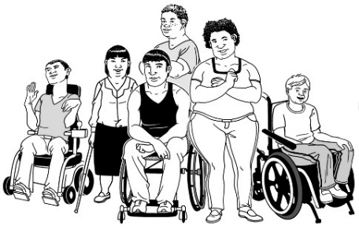
disabled in different ways
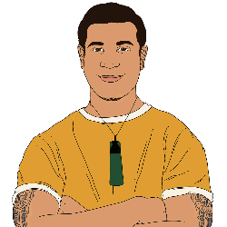
different ethnicities like:
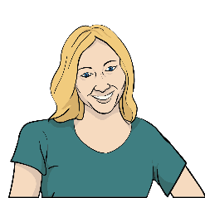
- Māori
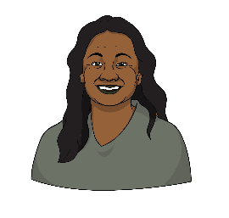
- Pākehā
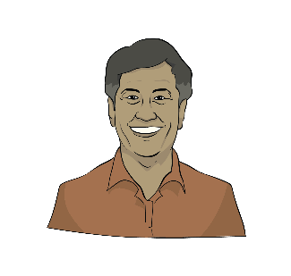
- Pacific Peoples
- Asian.

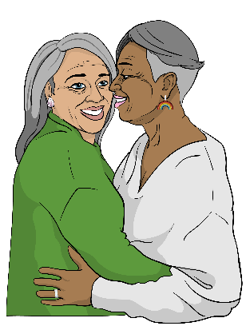
People in faith communities need to be able to:
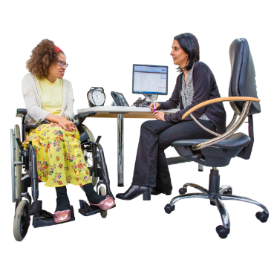
choose their partners / who they have relationships with
get the health care they need
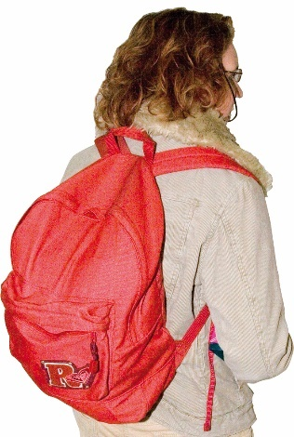
not have to worry about being cut off from whānau / family if they choose to leave the faith.
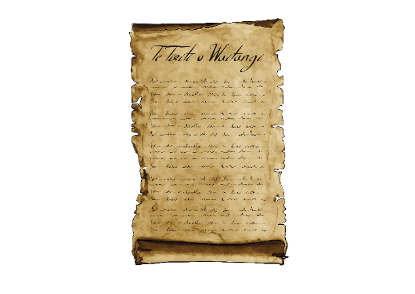

People doing pastoral care must show respect for:
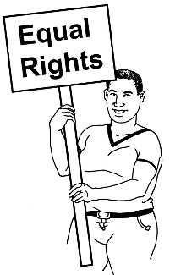
- te Tiriti o Waitangi
- human rights for everyone
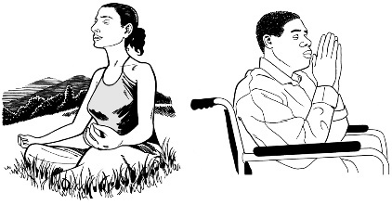
- the right of everyone to believe different things.

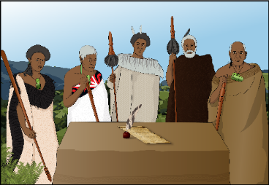
Te Tiriti o Waitangi / The Treaty of Waitangi is an important agreement between Māori and the British Crown.

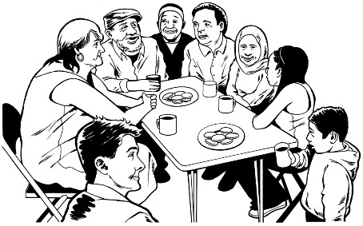
How care systems work in communities needs to be decided by:
communities
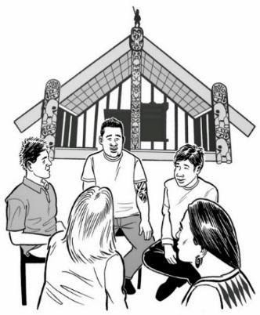
hapū
iwi.


The Government should give communities what they need to do this well.

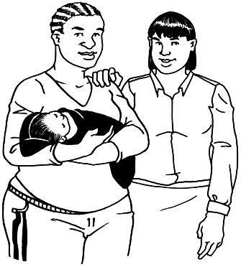
Survivors talked about local communities doing things like:
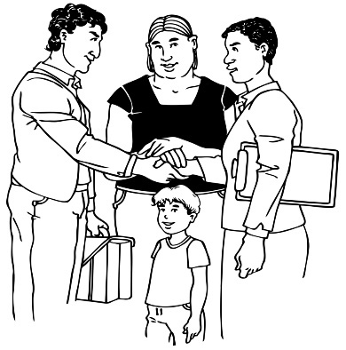
work to stop people needing to be in care
support services
care outside whānau.

Survivors and whānau / family told the Commission about where this is working well.


Survivors know that changing things will take time.

It will have to be done in different stages / parts.


Some communities will be ready now.

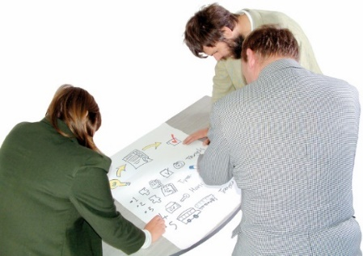
Other communities will need more support before they can start doing more:
services
support.

Most importantly survivors want the state / Government to make a big change in:

its attitude
how it does things.

The state means a similar thing to the government.

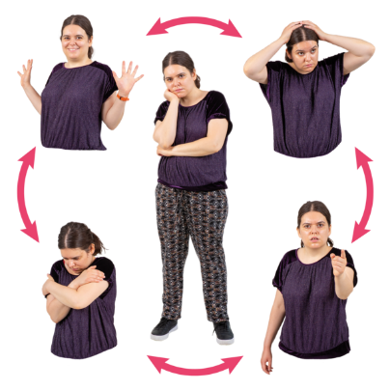
Attitude is:
how you think about things
the ideas you have that change how you do things.

At the moment the state:
works in a low trust way

focuses on:
- risk aversion which means not doing things because something might go wrong

- crisis response which is dealing with things only after something bad has happened.

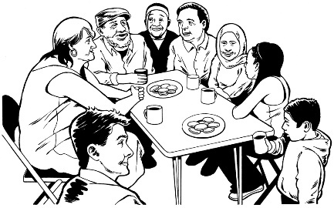
Working in a low trust way means:
- not trusting whānau / families and communities

- always trying to catch people making mistakes
- not giving people what they need in case they:
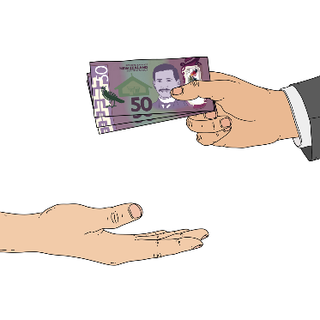
- do not need it all
- make a mistake.

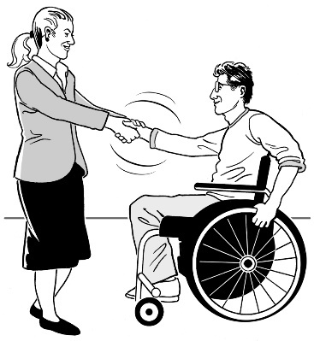
The state should be giving whānau / local communities what they need to look after their own people.

Summary of recommendations


The vision the Commission has for the future is called He Māra Tipu which means a growing garden.


The vision is what they want the future to be like.

State / faith leaders must make things right.

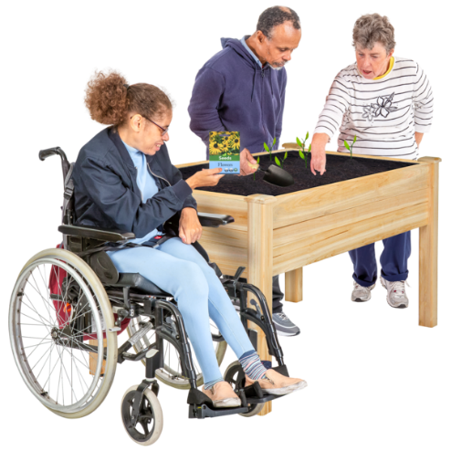
The care system must be made safe for everyone.

Aotearoa New Zealand must support whānau / families and communities to care for their loved ones.

Leaders must make things right

Survivors say that leaders need to:
Sorry
say sorry
take accountability for the harm caused.


Accountability means agreeing their organisation did things wrong.

These leaders include leaders of:
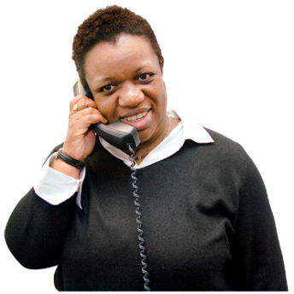
state / Government organisations including the Prime Minister
professional bodies
care providers
faith / religious leaders.
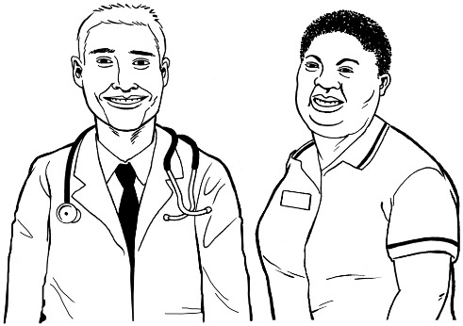
Professional bodies are organisations of people who have jobs like:

doctors
nurses
lawyers.

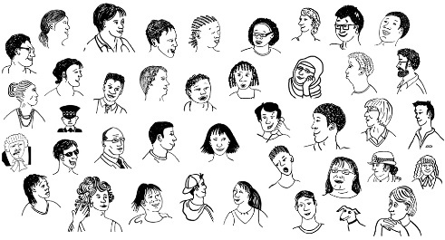
The apologies need to be public which means everyone can
read / listen to them.

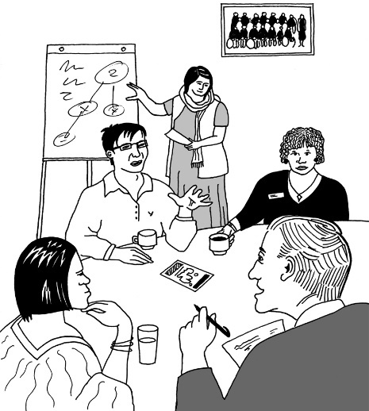
Apologies do not mean anything unless change happens as well.

State / faith-based institutions must make the puretumu torowhānui scheme happen.

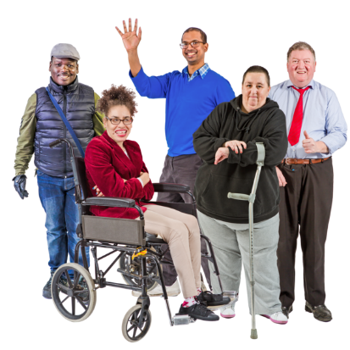
Puretumu torowhānui is a way of trying to make things right for people who were abused in care.

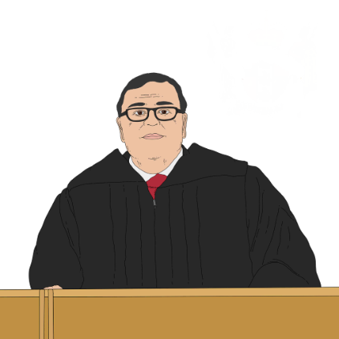
Puretumu torowhānui needs to happen now.

When survivors are taking people to court about abuse / neglect they should not have to wait a long time.


The courts must make sure their cases are dealt with soon.

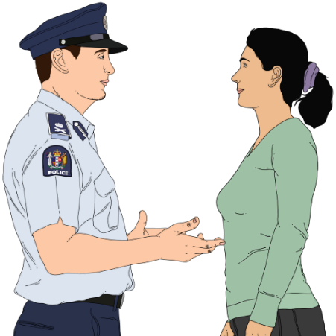
NZ Police should set up a unit for dealing with those responsible for abuse / neglect in care.

Keeping everyone in care safe now

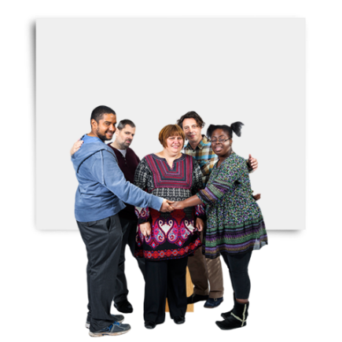
Aotearoa New Zealand must do everything it can to make sure our care system is safe for everyone.

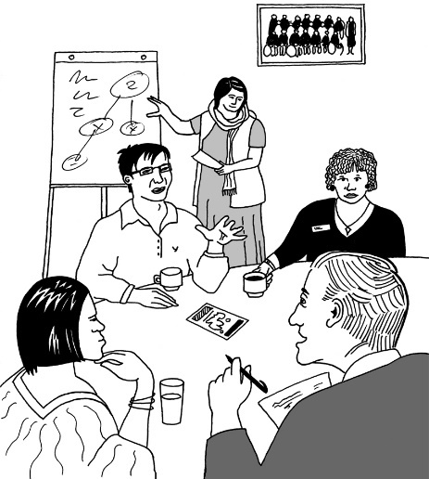
This needs political leadership on:
stopping abuse happening
what happens when abuse does happen.

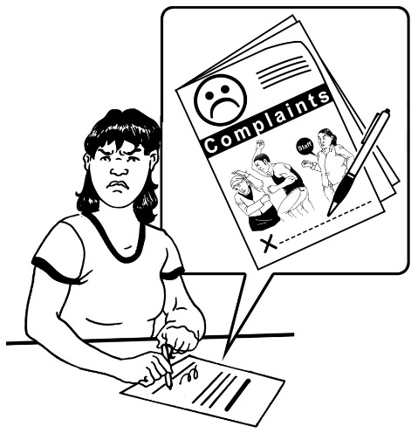
Complaints need to:
be listened to
have something done about them.


People who work in care need to be:
screened which means checked before they start their job

accredited which means making sure they can do their job well

trained
given good pay / working conditions.
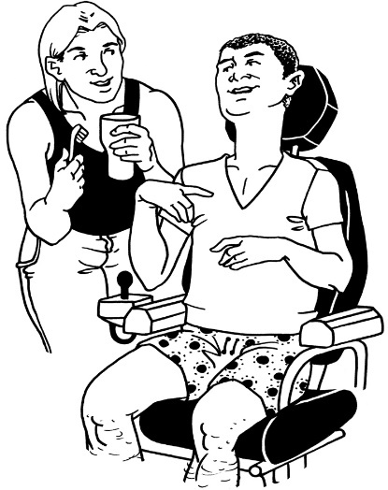

Working conditions means being treated well in your job.

It might mean things like:

having a safe place to work
getting time off when you are sick
having a boss who supports you to do well.
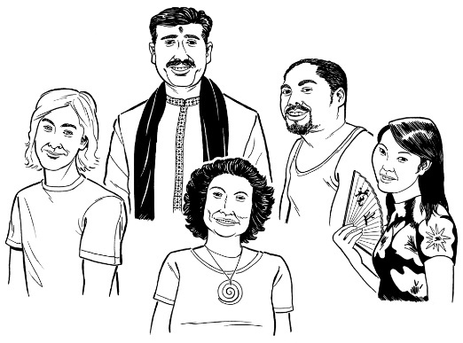
People who work in care should include:
the same kinds of people who are in care
people who have been in care.

The Government should do everything it can to move things:
away from the state / faith-based organisations giving care
to
communities providing care with close connections to whānau.

Supporting whānau and communities

Everyone in Aotearoa New Zealand has a part to play in making sure abuse / neglect does not happen.

Everyone needs to know how to be part of this.


We need to stop believing the sorts of ideas that lead to abuse.

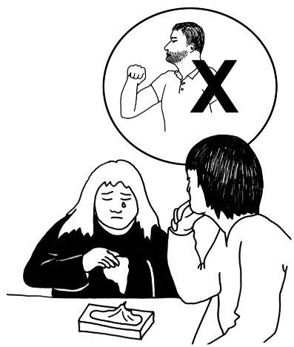
We also need to:
find out who is abusing people
stop them abusing people.

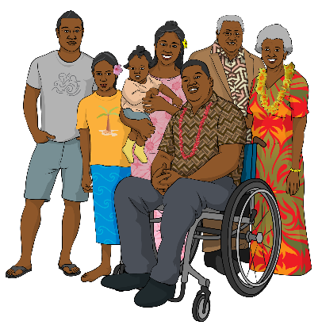
All whānau must get what they need to care for their loved ones.

If people need care outside their whānau / family it needs to be as part of the community.

It should not be in an institution.

All organisations must work in a way that supports:
te Tiriti o Waitangi
the rights of Māori in care.
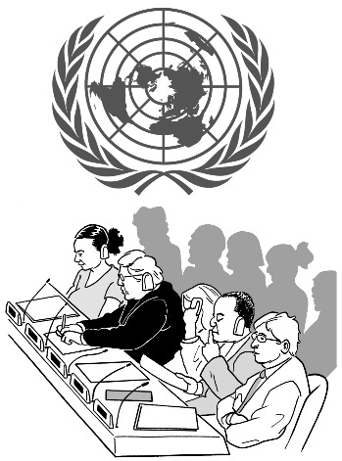

They must act in a way that fits what Aoteaoroa New Zealand has agreed to do about human rights.

This information has been written by The Royal Commission of Inquiry into Abuse in Care.

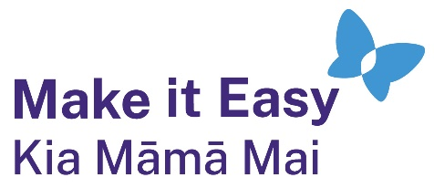
It has been translated into Easy Read by the Make it Easy Kia Māmā Mai service of People First New Zealand Ngā Tāngata Tuatahi.
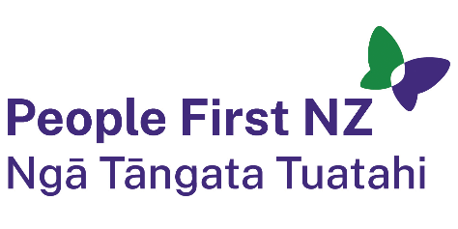
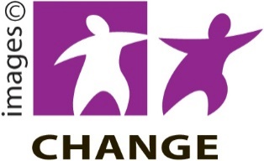
The ideas in this document are not the ideas of People First New Zealand Ngā Tāngata Tuatahi.

Make it Easy uses images from:


- Changepeople.org


            - Photosymbols.com

- SGC Image Works
- Huriana Kopeke-Te Aho

- T. Wood.

All images used in this Easy Read document are subject to copyright rules and cannot be used without permission.

